**Post last 39 (Line - 925208)**

**URL : <https://i.redd.it/g2m1qx4z12a21.jpg>**

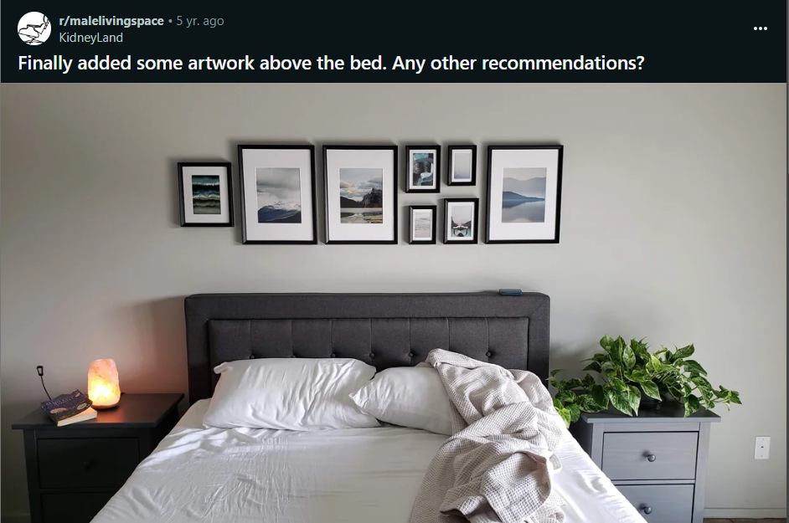

Comments :

1. You can maybe look into adding a linear light fixture or led tape light behind your headboard so it can up light the frames and maybe be an ambient light or reading light?

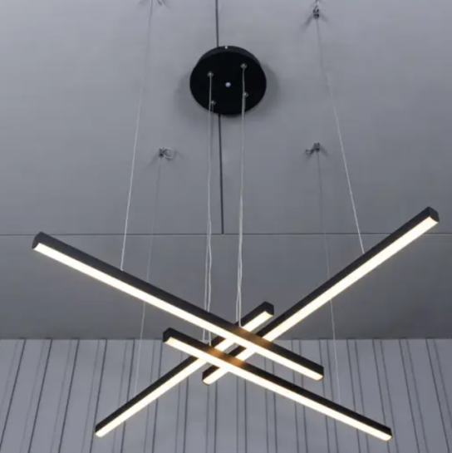 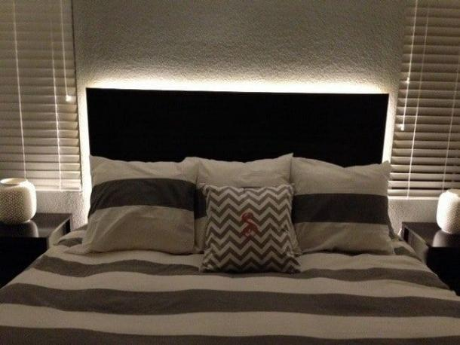

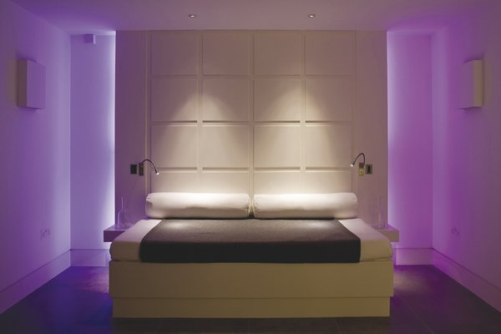 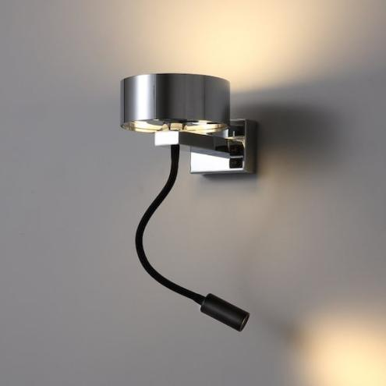

1. prints are too even imho. a little bit of offset will make the room less stiff. a square of squares above a square bed in a square room. a plant or two would also go a long way in livening the space. you need things that break the rigidity of the space. make it a little softer \n\nedit: I know you have a plant but it's very low and almost blends with the table. something with a little more height would create a good contrast.

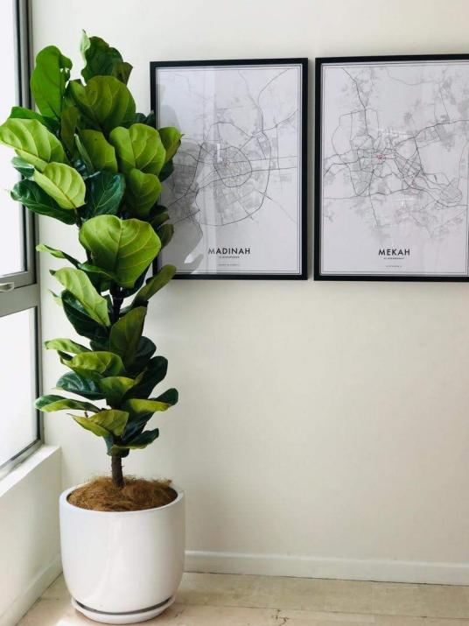

**Post last 40 (Line - 924832)**

**URL : <https://i.redd.it/1g8wecdc9de61.jpg>**



Comments:

1. If the Tory Burch fits what you typically carry in a purse then I\u2019d say keep it if it feels like better quality. If it doesn\u2019t fit everything you carry easily then keep the Kate Spade cause having to play purse Tetris is annoying.

 

1. They\u2019re both the same leather, if you keep the Tory in good condition the better buy is the Tory. But if you want it for storage then I would keep the Kate Spade
2. They don\u2019t monogram it deep enough into the leather. That\u2019s why I don\u2019t buy them they don\u2019t wear well
3. I like the logo has more of a warranty if you buy through Tory. Vs the one that will come off
4. I had a similar dilemma: a shiny, brand new  leather coach bag vs. a gently used, significantly older and smaller one. however, it was made in america--I guessed the manufacturing was hardier. that was five years ago. unless I have to carry groceries, I use it every day, and the only upkeep it needs is cleaning.\n\nmy point? when in doubt,  choose quality!  (but really inspect both, including where and when they were made.)\n\nand, btw? there's a bonus! you'll **HAVE** to edit the amount of stuff you keep in your bag. \n\ngood for your mind and your shoulders! \n\nplus, when you know exactly what's in your bag, you never have those panicked moments where you have to shake it around and stick you face in, wondering \"oh geez, I can't believe I forgot such and such!
5. From my experience, the leather on the Kate Spade is a tougher leather and withstands daily wipe downs (Covid era) and after years of use, they barely show any wear. The Tory Burch bags that I\u2019ve had show signs of wear in the corners easily (I think that after 1 month of sightseeing, the bag was looking very used. I baby my bags too, I wasn\u2019t wiping it down all the time (pre-covid times). Reselling wise, I\u2019ve seen that the TB sells for higher. Go for which fits your needs best. Good luck!
6. From my experience, the leather on the Kate Spade is a tougher leather and withstands daily wipe downs (Covid era) and after years of use, they barely show any wear. The Tory Burch bags that I\u2019ve had show signs of wear in the corners easily (I think that after 1 month of sightseeing, the bag was looking very used. I baby my bags too, I wasn\u2019t wiping it down all the time (pre-covid times). Reselling wise, I\u2019ve seen that the TB sells for higher. Go for which fits your needs best. Good luck!
7. Tory!
8. The Robinson is Tory Burch's signature line made exclusively for her retail store, costs way more, is much better quality, and will hold up better over time than that kate spade made for outlet bag.
9. Tory Burch

**Post last 41 (Line - 924545) --> Deleted**

**URL : <https://i.redd.it/x2cqli58nvt71.jpg>**

**Post last 42 (Line - 924356)**

**URL : <https://i.redd.it/89tp14viyjz41.jpg>**

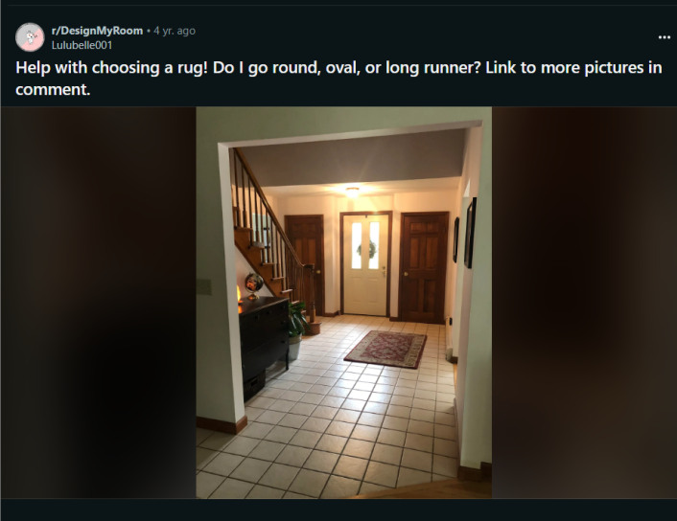

Comments :

1. Go big and select a solid or neutral color mix since the floor and woodwork are already busy.\n\nMaybe a long runner and a separate entry rug.

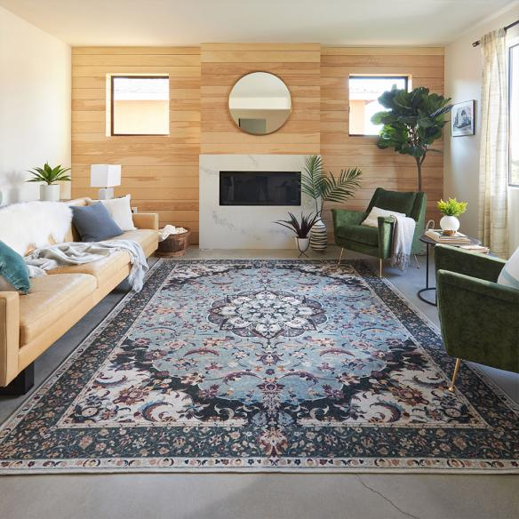 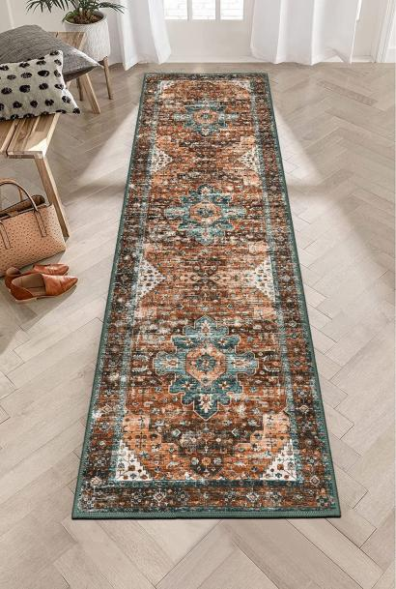

1. I would do entry mats like another commenter has said, but then do a nice, wide and long runner for the hallway. I would keep the entry mats super neutral - black or the natural jute (?) or wirey material. The runner you can have a little more color, but avoid a busy pattern.
2. Small mat in front of the door and something that will fill the rest of the space. Can't tell but those tiles don't look like 12\" but it looks like you can fit a 5x8.

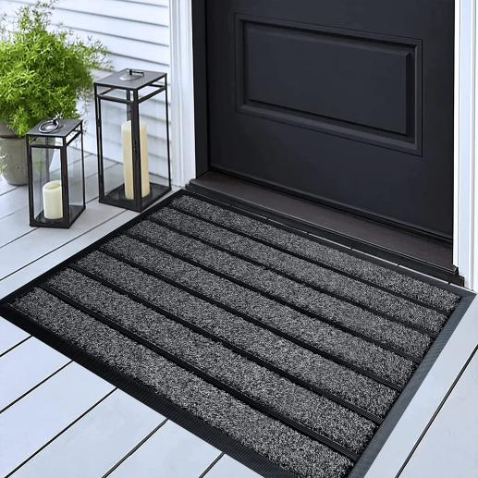

1. Door mat for front door and a runner. They don't have to match but maybe go very simple on the door mat, just something to catch the dirt and stuff. I would have the runner be a lighter color, a pattern is okay as long as the main color is cream or tan or something.

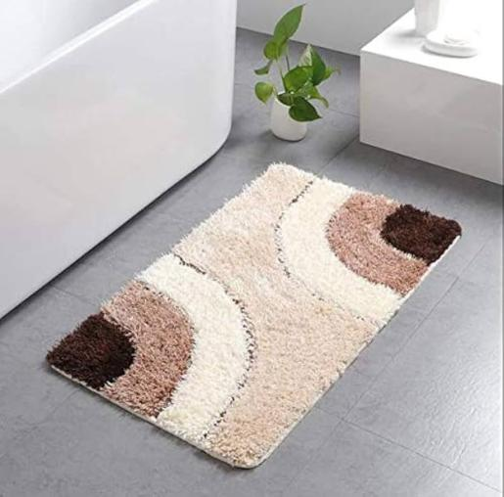 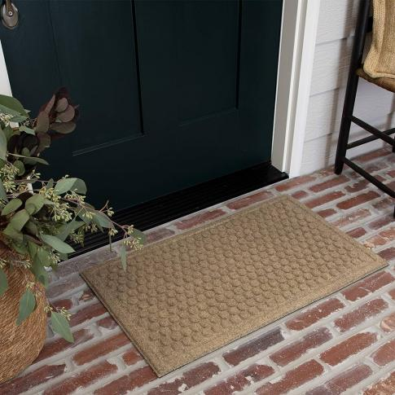

1. I wouldn't do an entry rug/mat unless absolutely necessary as I think it will end up being way too busy. The tile is already providing a lot of movement. I would do a rectangular rug to fill a lot of the entry hallway, the more of the tile and grout you cover, the more you'll tone down that movement issue. Go very neutral and zero to limited pattern on the rug. Beautiful home!

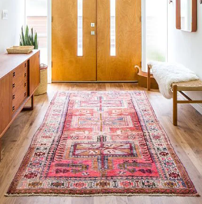

**Post last 43 (Line - 924129)**

**URL : <https://i.redd.it/1yczu9pmjy071.jpg>**

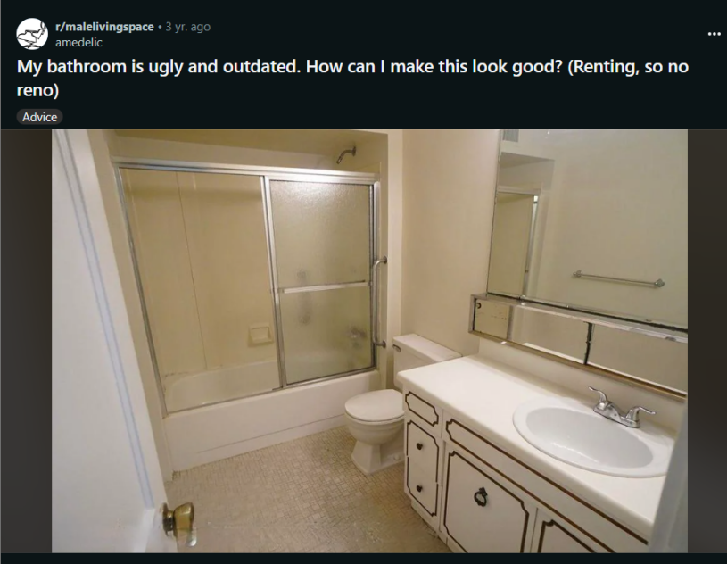

Comments :

1. Tension rod with curtain seems like a good idea to me. I got one of the society6 shower curtains and really like it, if you want something besides a generic store one.

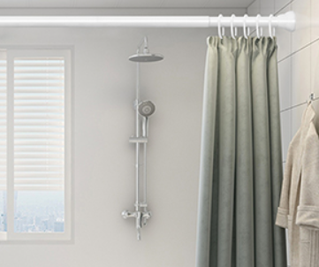

1. Disclaimer: I don\u2019t do design professionally at all. \n\nMaybe lean-in to the era? What is this, 80s decor? Also, if you can paint the walls I might go with something other than cream to just break the whole thing up a bit. And if you can paint the cabinets to give them a different look as well I might do that. Lean into the retro feel with accessories like from [here?]([URL] Maybe something like #8 or #10 [on this site ]([URL] for inspiration.\n\nEdit: because there\u2019s sooo much mirror I\u2019m guessing just a few colorful pieces on the opposite wall will go a long way since they\u2019ll be reflected.

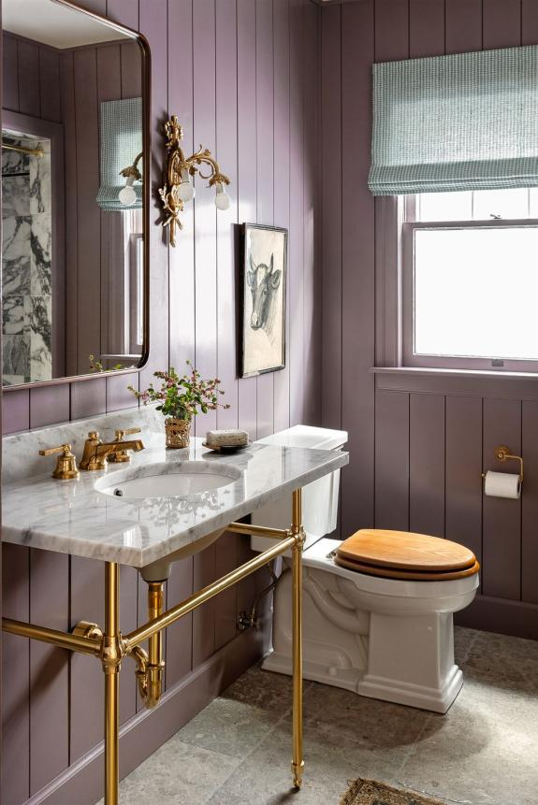 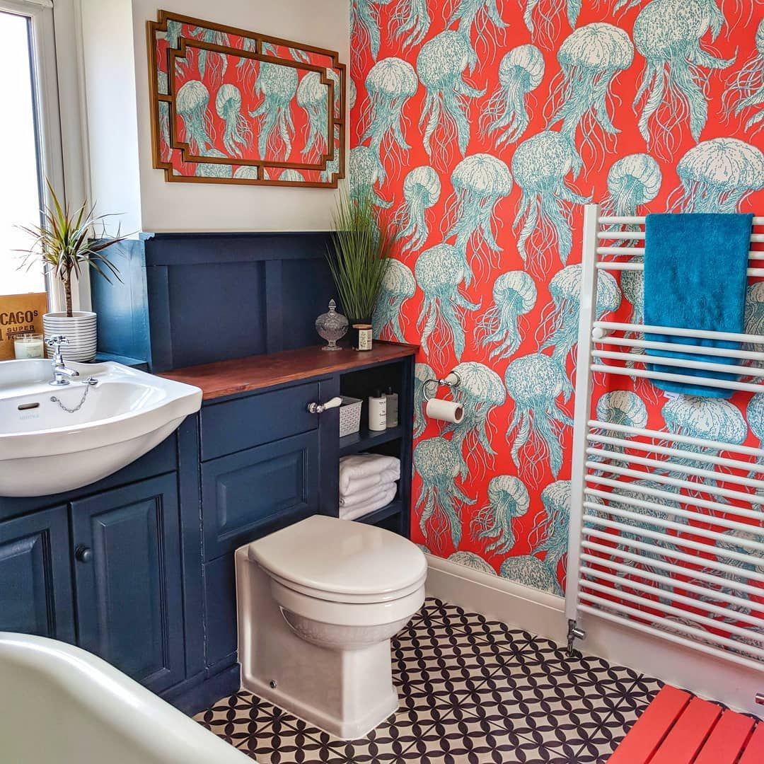

1. Honestly, the style is what it is. Trying to hide/masquerade things makes it worse, in my opinion. Just accept the funky style and run with it and it might actually turn out pretty unique and awesome. Once it\u2018s filled with some towels, products etc it looks friendlier already. Maybe a plant or two, bath rugs, and be ready to embrace the disco style. It\u2018s got potential.

 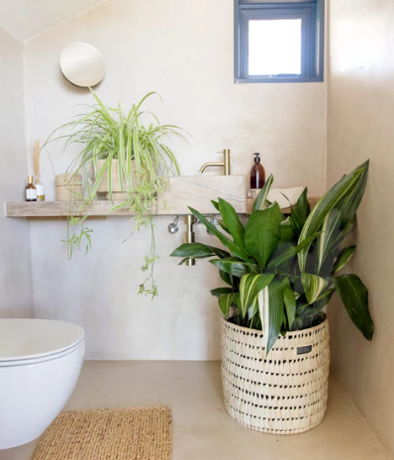

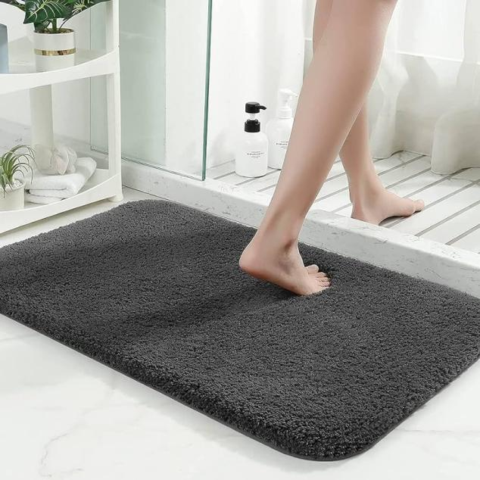

1. In the words of Ludacris, \u201cMove, trick! Get out the way!\u201d\n\nBut really, find some nice rugs and coordinate that with your knickknacks on the counter. Also add a plant or two on the counter.
2. Indoor plants might liven it up
3. Add some hanging plants (like pothos) if possible with command hooks. Add a bambo/wooden floor mat for some warmth. Add color matching modern hardware. Looks brown I think? Add maybe olive towels for a color matching pop of color (not sure on this one not sure if floor is a clashing yellow). Add some artwork too, maybe a photograph

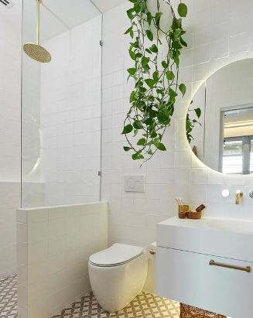 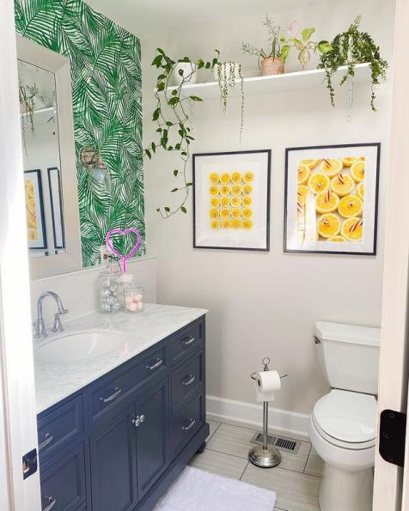

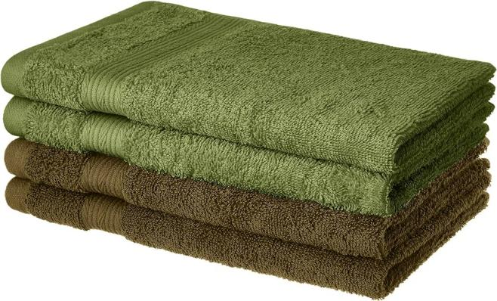

1. paint the cupboards black and replace the handles with brass and get a fluffy carpet on the floor or something nothing else you can really do since you're renting unless you are prepared to spend money on something you wont get back

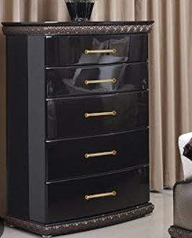 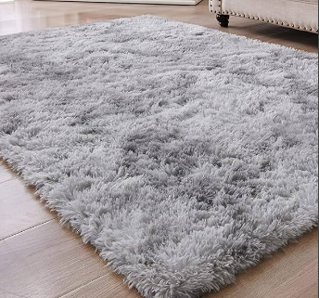

1. Peel-and-stick floor tiles; removable wallpaper; contact paper on counter; switch out the knobs on the vanity, and paint the grooves the same color as the rest of the cabinets (seriously doubt anyone would mind if you did that; might not even notice.\n\nAdd a rug, tension rod and shower curtain, art, attractive containers for your toiletries. Use removeable adhesive strips to put a frame around the mirrors. Towels on the rod that go with the shower curtain and rug.

 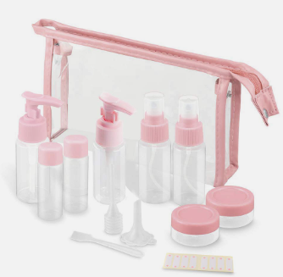

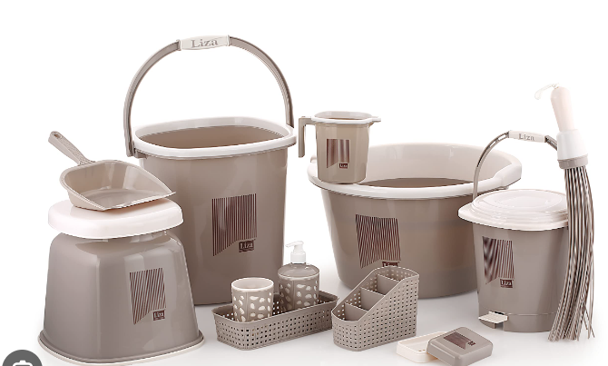

1. Add some shelves above the toilet and put some plants on there (real or fake). I got these: [URL]

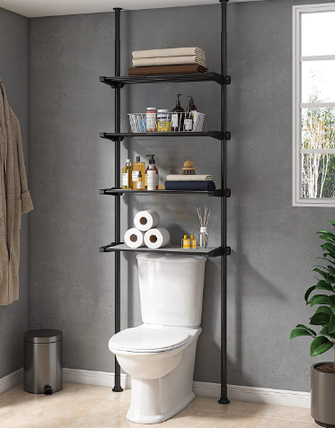

1. Carpet for the floor.  The bathroom kind.

**Post last 44 (Line - 923800)  
URL : <https://i.redd.it/zsguidq52vg61.jpg>**

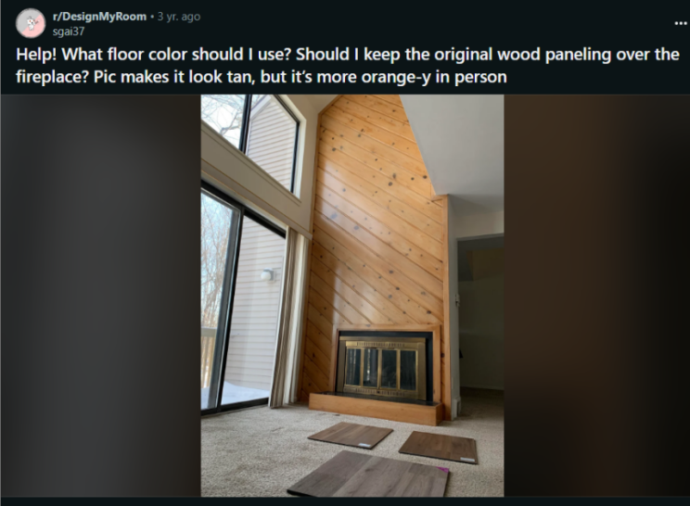

Comments :

1. Have almost exact same fireplace and it was gold like yours.  I took off the gold and spray painted it with rustoleum high heat matte spray paint.  Made a huge difference, looks great and only took like 10 minutes.  You might like the wood paneling more if gold is gone.\n\nDont do the gray toned flooring.  Been reading in this sub how that trend is on way out and will look dated in 10 years.\n\nEdit: link to spray paint here for type I used, they also have a brush on type. [High Heat Spray paint]([URL]

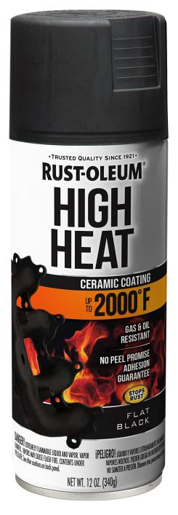 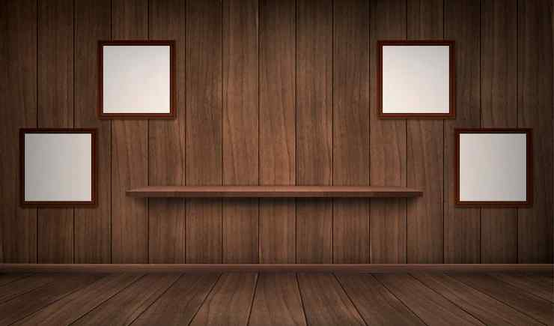

1. I like the darkest sample.  I think the gray is very trendy but will look dated in 10 years.  The knotty pine is oh so 70s.  I don't hate it, but I'm not a fan of the hearth.  My neighbor just covered her 70s brick fireplace with [split-faced stacked stone]([URL] in white quartz.  It has a bit of a sparkle to it which is true to the 70s era, but looks more modern than the knotty pine.

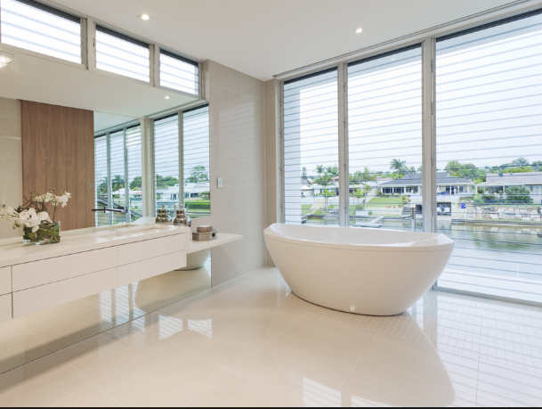 

1. I think the top right would add some nice warmth to the space.  The paneling isn\u2019t my style, but I could see it looking nice with the right decor.
2. IMO I really like the wood paneling especially if its just this accent wall. It feels like a classic cabin, but there are some details that bother me. First is the frame around the fireplace and the hearth which accentuate that the fireplace is not centered on that wall. Keeping it or altering it is up to personal taste, and it could be painted in an accent color dependent on your decor, but something like a gray-green comes to mind. Do you plan to hang anything above the fireplace? Can you eliminate the frame and extend the hearth/add a mantel that fill the whole wall?\n\nAre you re-doing the floors in this room or throughout the house? I think any of those would probably work, though its a little hard to tell, and the rest of the house might dictate the choice. In this photo I might go with the back left because its neutral without being too gray. The one in the front might be a lot of contrast, plus I think the trend for gray floors is a trend that may not last long.



1. Keep the paneling, use the top right flooring, and put a more modern fireplace screen on the front and I think you\u2019ll love it.
2. Dark floors paint the chimney wood  white or a vintage green
3. If you keep the wood do top right. Both of them have orange undertones so they work together while being different enough you won't feel swamped in orange.
4. Replacing the wood around the fireplace with brick or stone would look good but be an investment, be sure to choose something un-trendy. The floors should have the same thought. If you are buying materials that last \"forever\" don't do a \"look\" that won't. The fire place wall could be painted ( especially white) or stained a more neutral color. That would gain you a new look for a small price and give you time to decide on something more luxe. \nI might never again invest in something that \"lasts forever\"...I know I get bored in 10 years!
5. Also, It's perfectly okay that the fireplace is off center; a tall plant would love  that corner. Adding a mantle ( dark mantle on white \"shiplap\" look) could be done...but is a very different look and not the original intent.
6. Lots of options here - here's another to consider!\n\nI think the wood is beautiful, but the colour is not. I would look into whether it's possible to strip and restain the wood in a more neutral, natural shade, and go with the advice to eliminate the gold on the fireplace.\n\nTbh, I don't think any of the wood floors will look nice with the problem of the orange wood. If it has to stay for now, I would consider getting a medium to light grey tile. I think that would look a little brighter and cleaner than a sea of brown and orange wood.
7. Paint the walls (not the wood) to tone down the oranginess of the wood. If you like light colors, try [S-W Sea Salt]([URL] It helped with a lot of my orangey wood. \n\nFor flooring, use one of the brown colors in the background. They are true wood colors and will look good with your impressive accent wall as one cohesive scheme.
8. In case you don't know, there are also metal versions of those type of panels.  Lots of types, treatments and patterns.  I was going to change my fp out to metal last year.
9. I'd paint the wall white, get ride of the brass around the fireplace, and then any of the floors would look great.
10. Devil's advocate today. :)  I do like the gray flooring and while I agree it may be outdated sooner than the other colors, I tend to change my flooring due to wear and tear by the time it is outdated.  I like the accent wall comment (below) if you keep the wood on the wall.  Otherwise, I would put stone on parts of it and leave the upper portion something different.  Very cool.  Best of luck!

**Post last 45 (Line - 923589)**

**URL : <https://i.redd.it/tghdxumxkg941.jpg>**



Comments :

1. I love it with the veil ! I say go for it,you only get one occasion to wear one and it won't be for the whole day/night.\n\nThe dress and veil together are gorgeous !
2. OHMYGOD THAT LOOKS SO GOOD ON YOU! It\u2019s so perfect and flowy\u2014gonna look SO GOOD in wedding photos!! WOW!!
3. Also, I\u2019d say go for the veil! You can take it off once you start partying, so you\u2019d get the best of both worlds :))
4. Yes to the veil - it looks great!
5. Veil for sure!!! The thing that will bug me about them is when the decision to keep it over your face during the ceremony is chosen. Reason being is you can\u2019t see your face, so all the photos for memories, the expressions of happiness and love are all covered. How you have it hanging in the back is beautiful! \u2665\ufe0f\ud83e\udd70\u2665\ufe0f

**Post last 46 (Line - 923407)**

**URL : <https://i.redd.it/ixvweaqzeoz21.jpg>**

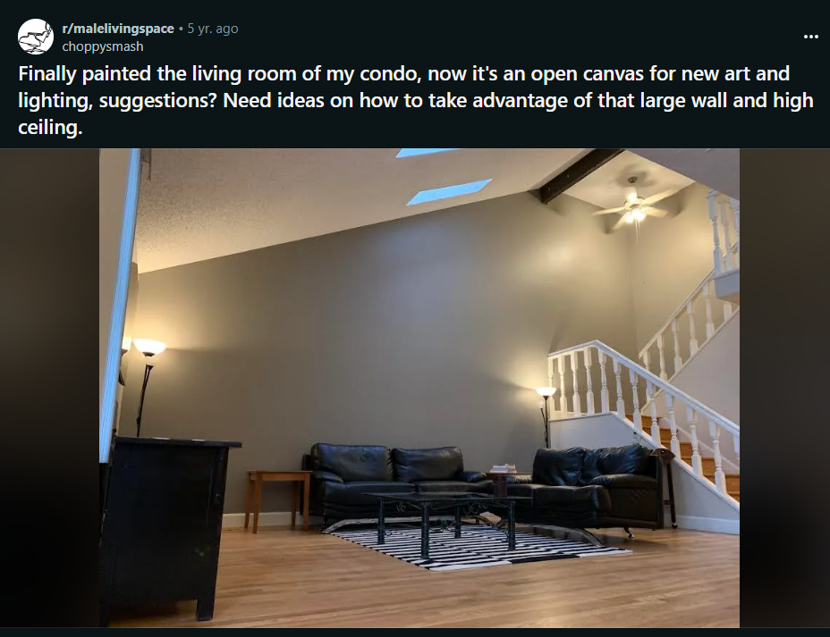

Comments :

1. I\u2019d say a large art piece or mirror directly over your couch. \n\nI\u2019d probably go for some framed photos on other parts of the wall.
2. >e art piece or mirror directly over your couch.\n\nA giant piece of modern art would be cool.
3. Step one: cut a hole in a box\n\nStep two: put the box in your passenger seat, go to Home Depot or Lowe\u2019s, get a medium-height plant & pot, buy them, put them in the box, and buckle them in. That way, they won\u2019t spill all over your car\n\nStep Three: bring the plant up, put it in your living room.
4. Oh! You can have some [cityscape wall art]([URL] or some [seascape wall art]([URL] They're refreshing!

**Post last 47 (Line : 922686) --> Deleted**

**URL : <https://i.redd.it/w3uc3tgvf3071.jpg>**

**Post last 48 (Line : 922337)**

**URL : <https://i.redd.it/jothotgz0vr41.jpg>**

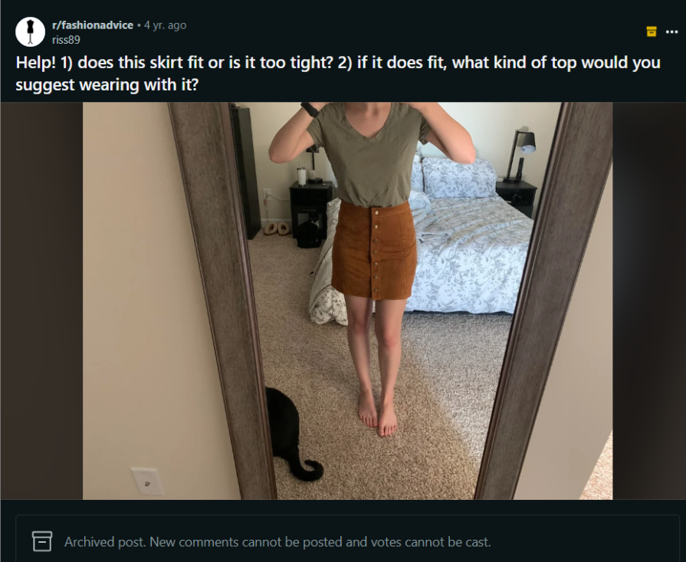

Comments:

1. It looks like it fits perfectly! I\u2019d go with a cute off white sweater tucked in, or maybe a white crop top
2. came here to say a white crop top. maybe even the eyelet/ lacy kind like this one! \n\n[URL]
3. Or in a nice cream color would also work, I think.
4. It fits, but I don't think that shirt goes well with it. I would suggest something fitted and tucked in, or wear it kind of high waisted with a crop top. Showing a little mid drift like that is a great way to emphasize your waist, especially with your body type I think it would look great. For shoes I say boots or some cute tennis shoes
5. It looks good. Can you sit down with it without trouble? That would be my only concern. \n\nAs for tops, there are so many options! Maybe something lighter? Like [this top]([URL] Kat Hudson wore Almost Famous.\n\nOr go in the opposite direction and wear all black to make the skirt pop, like in [this]([URL] outfit or in this [one]([URL]).\n\nA [jeans shirt tucked in]([URL] would also look good, I think.
6. Cute skirt. It would go with plenty of different tops. A band tee with sneakers would look great, but so would a turtleneck with boots, or a flannel with booties.
7. Skirt looks great. One of my fav styles, you're similar to my shape and high waisted works on us. Any top you wear must tuck in, including sweaters in my opinion. Light breathable fabrics will give you a glamorous breezy look. Button up blouse for formal, loose t shirt or comfy tank etc for everything else. High waisted stuff can be work like everywhere. Can I ask where you got it?
8. I think I have the same skirt, I like to half tuck sweaters and loose tops, and it goes great with knee high boots.
9. It looks like a great fit! For cold weather, I definitely echo a cream, white or black sweater, tucked in or with a French tuck ([any]([URL] [of]([URL] [these]([URL] would be cute). Would also look great with black tights and boots/booties!\n\nFor warmer weather, I'd do a white top (like [a tank/bodysuit]([URL] a [simple tank with some lace]([URL] or a more [dressed up top]([URL] or even a fun [graphic tee]([URL] to dress it down. You could also wear it with a denim jacket and booties or wedges/sandals.
10. I would recommend a white or black sweater with matching shoes! Love the skirt
11. I had a skirt just like this! I wore a loose off white short sleeve button up with it :) I also put a maroon light sweater with it in the fall that was cut right where the skirt hit my waist :) I hope this helps!
12. I say wear it with a milkmaid trend type top!
13. It looks like it fits well! I personally think wearing baggy sweaters or shirts tucked in on just the front or all around creates a really good look. Or a turtleneck layered with a short sleeve shirt or tank top. Adding sock booties (I'm not sure if that's the correct term for those kind of boots, but that's the best way I can describe them) would create a really classy look as well!

**Post last 49 (Line : 921966)**

**URL : <https://i.redd.it/hup30g5d4pa31.jpg>**

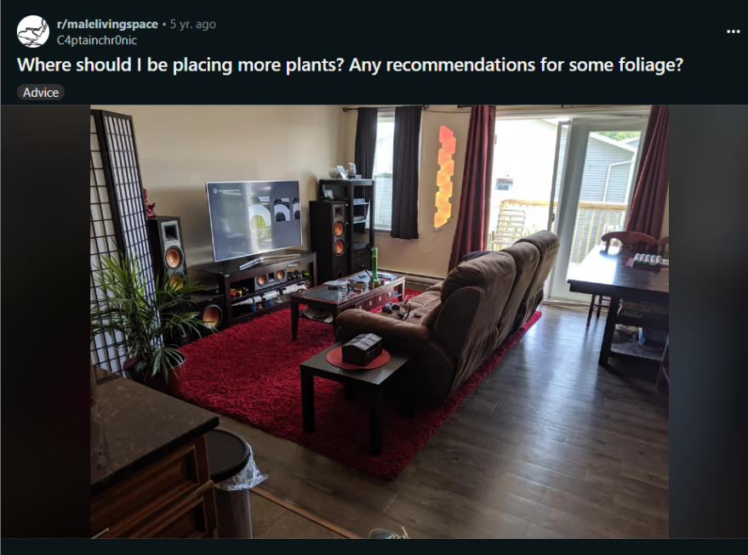

Comments :

1. I see you have a vase on the coffee table already so you could put a plant or even some herbs in that.
2. I can see one going on top of the cabinet where your media consoles and stuff are held if you re-arrange whatever is on top to the bottom.\n\nCoffee table could also have one.
3. You can get small pothos plants at most big box home improvement stores for just a couple bucks.  Then just get a few small cheap pots and you are good to go\n\npothos are easy to grow and take care of and will grow in all manner of places in your home and you can put them pretty much anywhere in terms of decor
4. I think the shelf in the far corner is crowding that space. Maybe replace that with a plant
5. If you're able to put a small hook (screw in type) in the ceiling above your media shelf in the far corner, you could have a nice hanging spider plant or similar. There's good lighting in that space. I also just completed the Saturn V lego build!

**Post last 50 (Line : 921736) --> deleted**

**URL : <https://i.redd.it/rca37dppq0n61.jpg>**

**Post last 51 (Line : 921292)**

**URL : <https://i.redd.it/g4ytv185mn571.jpg>**



Comments :

1. So many options! For something safer, I would go with a pleated black skirt. For some fun, I might even play with texture and try black (or maybe red) leather pants. You could also try black plaid trousers. Or pleated trousers in general!
2. Black jeans or an olive plaited skirt please. \n\nWahsed out denim doesn't do justice at all.
3. Make sure they atleast are till your knees. Anything short and it would be a blunder since the top is already for the short look! \n\nAlso maybe tie your hair up in a high bun or make a plait of it? Reason being the high collar thing already Hides your neck so the only thing left to compliment are your earrings! And your face doesn't remain hidden. Go with loop earrings if u have those but even long hanging ones work fine.
4. I would recommend wide-legged pants. [Zara]([URL]
5. Agreed. The top looks charcoal grey, so I think maybe a bold colored, wide-legged would look amazing. Perhaps red or mustard?
6. Black big leg pants
7. Not sure how well links will attach on mobile but I'd say instead of a straight or skinny cut, a tapered style like [this]([URL] or a wide leg [like this]([URL] would really compliment those sleeves. Disclaimer: I haven't bought from those shops I've linked and can't speak for quality of those specific pieces, I just googled the styles I had in mind and picked links based on appearance.
8. wow, i love this top, great pick!\ni'm afraid it might be an unpopular opinion but i believe in this too strongly so i will just lay it out here - a white denim mini skirt or shorts!\ni think those will look fantastic with the top, and maybe try some sneakers underneath? (Preferably chunky, or something like hightops?)\nand like someone said in one of the comments, you should definitely put on some dangly earrings with your hair in a bun - will be a great look!\n\nfor a bit of a formal look, you can try slightly wide legged black trousers? maybe something like formal highwaisted trousers, nothing skin tight. That would give a nice look too! \nAlthough it is full sleeves, you can pair the trousers look with a light blazer too!
9. sorry i tried attaching a link, didn't work. but anyway this is the only trousers i have in mind & it's my aim to get these asap any how! \n\n[URL] \n\n(pls refer to the dancer in the white shirt - ryujin!)
10. Have you tried some skirts with this top. If I'm guessing right [this]([URL] kind of skirt will look good.
11. omg I wanted this top so bad but it was too expensive for me huhu!! the others already gave nice suggestions so I'll say something more out there. vibrant colored pants would look great! [Teal]([URL] or [Yellow]([URL] (for a 2021 pantone colors of the year look lol) and apple green are colors I recommend. Floral textured bottoms, like lace or brocade, would look so cute! I think u could also get a [lacy dress](zapaka.com/products/asymmetrical-white-lace) to wear it underneath so that the pattern would peek through the cut out part.

**Post last 52 (Line : 920815)**

**URL : <https://i.redd.it/vx7ukq1yynx81.jpg>**



Comments :

1. I would exchange and either size-up or go for a different cut. If you size up, you could always get the waist taken back in some. Also, maybe this is supposed to be the style, but I think they look way too long? For me , the combination of the tight waist but then loose/long legs looks a little off or something.
2. Maybe try a different style, you could get something way better !
3. Return and look for slim mom jeans
4. You dont have to give them up if you pair them with platform shoes. Personally, I think lighter colored platform sneakers would be great
5. I have a pair of baggy mom jeans, i got from target. They stretch a lot when you wear them, they fit slim on the hips right out of the dryer, but after an hour they turn into the most comfy baggy mom jeans. And they are the perfect length for petites! \n\n[URL]\n\nOmg idk why that link is so long
6. Also maybe try the xtra short! i\u2019m 5\u20190 and even short is too long on me
7. You need them looser and shorter
8. I think they\u2019d make a cute distressed pair of shorts
9. Go for a different style of jeans this isn\u2019t as flattering for you!
10. Exchange and cuff em up!!
11. I have a similar height and build. \n\nInfo: are these high waisted? \n\nIf so, you can cuff them, wear a cute belt and a crop top and lowtops. Easy casual outfit. \n\nIf not, return there\u2019s no saving them
12. Just cuff them and they will make a very cute boyfriend pair of jeans.
13. I recommend american eagle x-short jeans. Xshort jeans are meant for those 5feet and below.
14. They fit beautifully, paint some majestic colors and flowers on them\ud83d\udc97

**Post last 53 (Line : 920617)**

**URL : <https://i.redd.it/du1tj8oed0z41.jpg>**

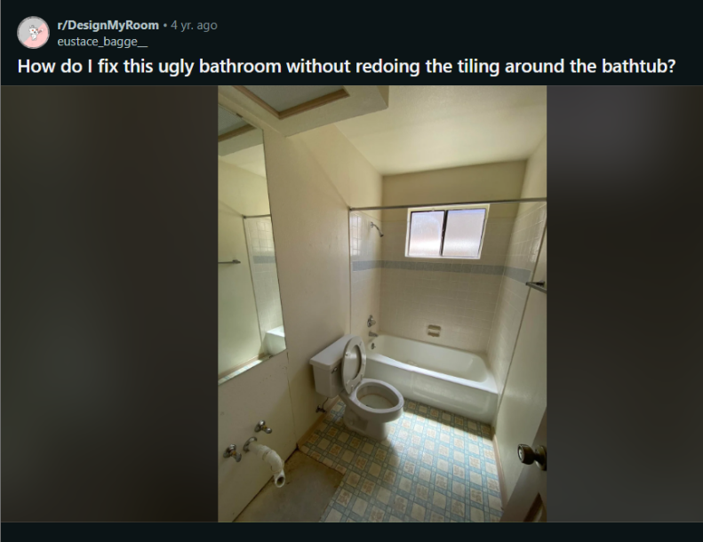

Comments :

1. The tile isn\u2019t a problem. It\u2019s pretty neutral, and once you put up a shower curtain it will barely be visible. The floor is terrible, though.  Just start deciding on paint colors and flooring. Are you installing a vanity, or do you already have one?
2. Just redo the tile.  It\u2019s an easy job and will change the whole place for the better.  If that\u2019s truly not an option then flooring (lvt) is easy water resistant and paint for the walls would be good too.
3. If you really dont want to touch tile then dont. Floors, walls, and a curtain are more than enough.
4. The floor looks like laminate and not tile, right? That should be relatively easy to replace. The toilet is worse than the flooring though. Hopefully you can clean it, if not I\u2019d put replacing that as the top priority. If you were referring to the tile in the shower I think it\u2019s looks fine. It looks pretty recently done, the grout is nice and clean.
5. The shower tiles won\u2019t be that bad once you get more modern tapware & replace that toilet!
6. I would also (perhaps above the toilet) pop some shelves up to put up pictures, and have trailing plants on. A splash of green / life from house plants does wonders to spruce up a place!
7. Update the hardware. I see the door handle and the towel rack are very mismatched. And having a shower window means you can turn this bathroom into a pretty great greenhouse, plants will love it.
8. That shower tile is just fine. The floor tile however....new floor tile, paint on walls, new vanity and boom you're done! Show us the after!

**Post last 54 (Line - 920439)**

**URL : <https://i.redd.it/zzezefdkx4v41.jpg>**

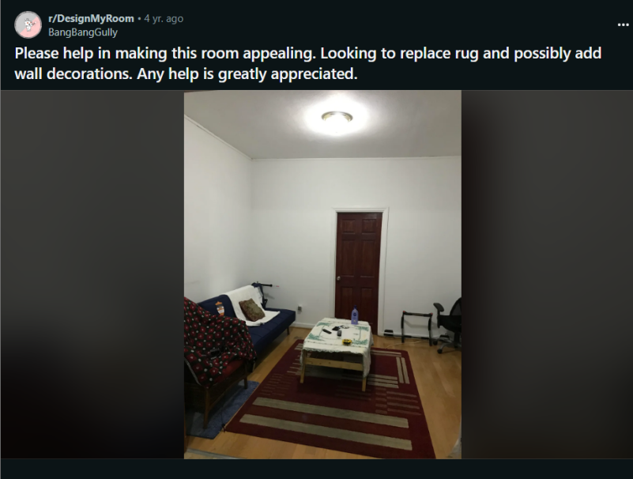

Comments :

1. I say decorate with what makes you happy.  \n\nI do think your lighting needs an upgrade.  Ditch the builder grade ceiling fixture. Looks like you have some pretty high ceilings, so you could even get something that hangs down a bit.  But don't let that be your only light source. A floor or table lamp or two will add dimension and enable you to set different moods.
2. I would add large throw pillows for the couch and add some large wall on the wall behind. I would remove the tablecloth, it doesn't match the rest of the room. Lighting is very important to make a room look nice, I recomment adding a dimable floor lamp next to the couch, or maybe a small lamp on a side table. \nThe rug under the chair looks very small, I would one large carpet to replace the two other ones, make sure that it is big enough to reach under the front legs of the couch. You can check out the Area Rug Guides in the Side.\nIs this a basement room? If there is some natural light you could get a plant, otherwise you might still consider a fake plant.
3. I'd put some pictures or one big frame with a photo you like above the couch and a neat bookshelf next to the couch
4. A big improvement is just getting rid of that carpet and the table on top of it.

**Post last 55 (Line : 919625)**

**URL : <https://i.redd.it/s9sobue28x3a1.jpg>**

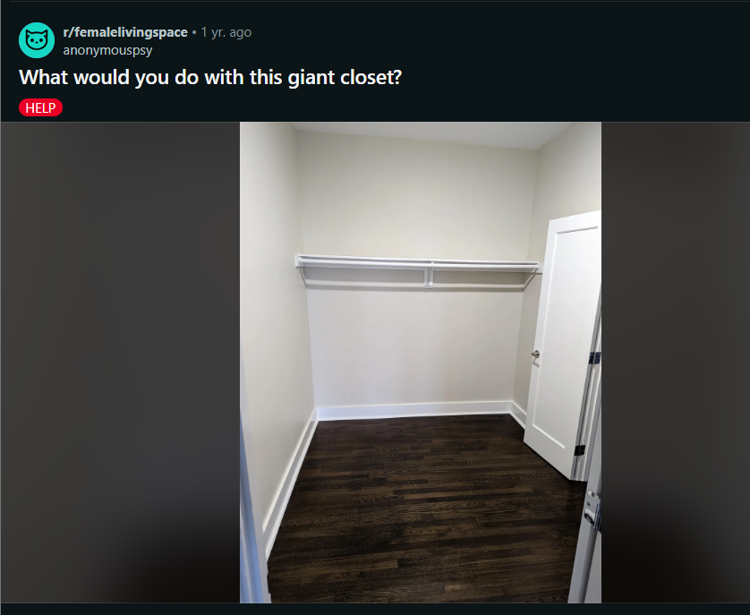

Comments :

1. I live in SF too! Should have guessed with the bay windows! West is great. :) Most houseplants besides cacti and succulents should do great within six-ten feet of the windows. You could get some plant hangers to hang from the ceiling or wall too. I would recommend checking out Sloat's Nursery or Home Depot for affordable plants if you don't have very many yet. Ross/Marshalls/TJ Max has cute affordable pots and plant stands.
2. Sloat Nursery is the absolute best. They\u2019re a local chain and my family has been going there for decades. Outside of that, just do the local shops. SF is heaven for independent businesses and it\u2019s great to support them! My friends love a tiny plant shop on Fillmore a couple storefronts down from Haight. There\u2019s also Cole Hardware which has plants. That\u2019s just my old neighborhood though, you\u2019ll be able to find good stuff near wherever you are.
3. Bird of paradise is one of my favorites for spaces like that, they grow huge and make such a dramatic statement. I\u2019ve had mine for three years and have lugged that thing through each move haha, also, get a self watering pot for it! I also love pothos to hang from the ceiling and they\u2019re super easy to propagate
4. Hanging pothos right in front of that window!
5. 10000000% yes. Are you good with plants? Or new to it? Get some easy plants if your new! Like a pothos or zz plant. But honestly, to gain experience with plants you just gotta go for it and figure out thru trial and error. Go to your local nursery and show them this picture and says it\u2019s westward facing\n\nSO EXCITING
6. First thing that comes to mind for a plant is a monstera. Although takes up a lot of space depending on where you put it.
7. I'd probably put something tall on both sides of the windows
8. Under the windows (or even hanging in that wall) so that sun would hit the plants (and because i think It would look cool). I would put big leafy plants,maybe a monstera
9. Under the windows (or even hanging in that wall) so that sun would hit the plants (and because i think It would look cool). I would put big leafy plants,maybe a monstera
10. I have a similar window. I bought clear acrylic shelves on Amazon so the left side there's 3 rows of plant shelves and then cobbled together an Ikea plant shelf atop a little table where I have several plants next to the window with some plant lights positioned on the shelf. I used plant hangers above the two smaller windows to hang plant lights because I am north facing in the PNW. Finally I put hooks in the upper \"ceiling\" part of the bay window I have to hang plants in various spots though I have a really large window in the middle.\n\nYou could buy 3 acrylic shelves for those windows if you wanted to max out your plant collection. [I have been using these for 4 years without issue]([URL]\n\nThe shelves are great if you don't want to take up floor space with plant furniture. Edit: with the plant shelving you can experiment with different kinds of plants in your window too. I only use the left window with those shelves I linked because they were expensive :)
11. I would just look up indoor begonias! They are beautiful and fairly easy! Also ivys are just as pretty, with a wide range of variety and are also very easy tp tend to\u263a\ufe0f
12. A nice money tree!\n\nI have one names Johnny Cash.
13. I would probably put some aloe plants or some cactus \ud83c\udf35
14. Two tall plants by a table
15. For some stunning ideas, look up book nooks on pinterest. \n\nPersonally, I would build a bench seat for the window, put a shelf over the windows, book shelf on the opposite wall from the radiator, fill it with vines and succulents. If you want some aromatherapy and bonus cooking herbs in the cozy nook, plant a small pot each of thyme, rosemary, mint, and lavender.  A bonsai tree growing kit would be cool for this window too.
16. I live in an identical apartment and my rubber plant is THRIVING

**Post last 56 (Line 919417)**

**URL : <https://i.redd.it/floymg5gzis91.jpg>**

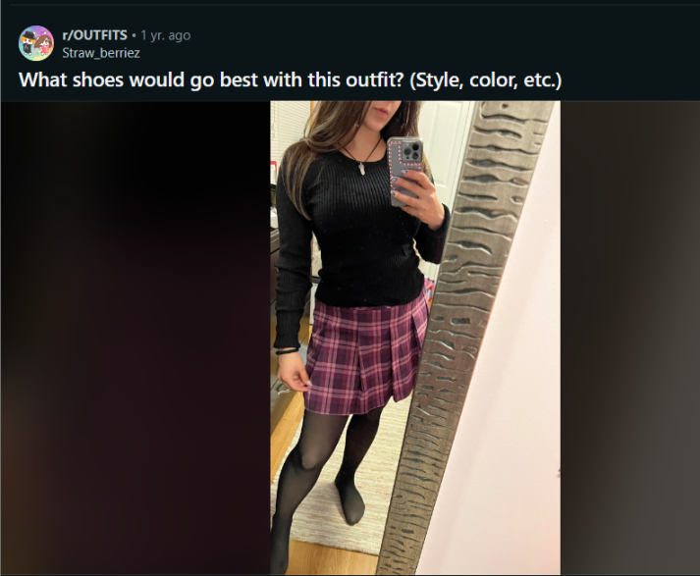

Comments :

1. Black loafers :)
2. Black mary janes
3. Black chunky boots or suede knee boots, in my opinion.
4. Black loafers with chunky heel
5. Black loafers with chunky heel
6. Black heels or boots
7. Black heels!
8. Got to go with black heels \ud83d\ude0d\ud83d\udd25
9. Pink combat boots

**Post last 57 (Line : 919064)**

**URL : <https://i.redd.it/silqlysefrc81.jpg>**

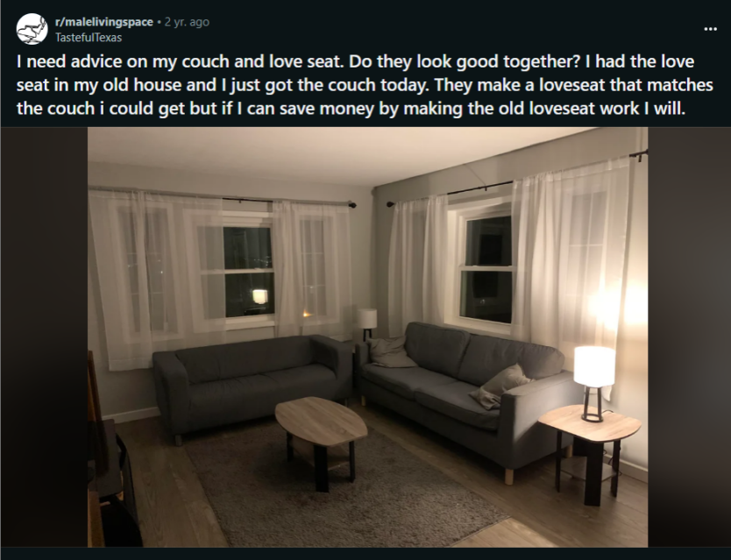

Comments :

1. They look good. I\u2019d add some color to the room though. Maybe a pillow, a blanket over the back of one.
2. Perhaps you need a lighter rug and pillows. It has a very dreary look to it. That being said, the seating is fine methinks
3. Maybe some throw pillows that match for each couch. Pulls them together maybe.
4. Definitely some coloured pillows that match on both, perhaps a throw. Maybe consider getting a lighter, or patterned rug too.. or just splash bleach on that one if you're feeling risqu\u00e9..lol
5. IMO you should maybe put the love seat up for sale and get a chair or even two in a color that is not gray. The couch and loveseat look too much alike so I think breaking it up by bringing a chair that is not gray will do the job. \n\nHowever if selling the loveseat is not an option I would try to spice the room up a bit by bringing in some colorful pillows, throws, a plant etc.
6. Looks good to me. Could use some led lights though.
7. They don\u2019t look good together and your curtains should reach the floor.
8. Maybe a larger coffee table? Might help pull things together
9. Perhaps new legs for both pieces from Amazon would also help pull the look together, maybe in black as you have other black accents around the room.
10. Bigger rug, something with color and matching pillows
11. I think loveseats / second seats work better when they don't match - like a statement piece. But these match too much and also not enough, which is a weird kind of space to be in.
12. Decorative throw and matching pillows on both couches. Get a bold print rug. Maybe add a valance to the top of curtains like a drape, you would not even need to add any hardware for that.
13. The white sheers really cement the grey-ness of the room. Pick a bolder deep color for the window treatment. Then stick with the primary color rule. If you get deep teal drapes, that\u2019s your blue. Now you need some kind of yellow, like a mustard and a red, like a port red. Adjust tone and shade for your own tastes.
14. Look you can change this place by changing the sheers into a colored sheers, bigger coffee table, an rug that combines with the sheers.
15. Maybe some cushions and pillows that aren't grey will help tie the two together. Maybe a throw as well. They're close enough that I think they can work.

**Post last 58 (Line : 918735) --> Deleted**

**URL : <https://i.redd.it/t72obzjiwht31.jpg>**

**Post last 59 (Line : 918221)**

**URL : <https://i.redd.it/4cupp56wlun81.jpg>**



Comments:

1. some dangly hot pink gem earrings! and maybe a small diamond necklace. i would lose the hat, but thats just me.
2. A fur jacket would look so cool!
3. A cropped fur jacket
4. Necklace for sure, and then a red or blue jacket.  Something with some color
5. Mid length loose fitted jacket over the shoulders in either white or black! \n\nOne gold statement necklace. If hair is up, match with gold earrings.\n\nClose-toed shoes
6. A couple of people have said to lose the hat\u2014I actually really like it! I\u2019d add chain link gold necklace, or layer fish bone with a thin pendant necklace. I second the fur coat!
7. You need a pop of color.  I like the idea of hot pink earrings or bracelet and a necklace.  I\u2019d also lose the hat
8. scarf or large cardigan/blazer
9. The pants won't shine if you add all that. I'd keep the rest understated. \n\nOversized blazer or other structured jacket in a neutral tone. Shoes should match the pants- black and closed-toed. \n\nJewelry should be delicate, can be gold or silver. But earrings/necklaces should be long.  \n\nPlus, a belt and clutch/purse.
10. Chunky gold jewelry would work so well with this!
11. Sheer white button down long sleeve shirt, black or gold belt, multiple necklaces
12. I feel like this outfit is a bit seasonally confused: I think of pleather as more of a cold weather item, so I wouldn't wear with open-toed shoes. \n\nAnd I would not pair with a faux fur jacket. The pleather is enough of a statement/hero piece. Faux fur might be a bit too over the top?  However I do like the idea of adding some sort of soft nubbly texture here! I don't know what your weather is like where you're at, but I would pair the pants with a cashmere or wool sweater, something soft, to contrast with the shine from the pants.
13. Add a nice watch too :)
14. Belt (chain or with gold accents) deep red, green, or gold glitter toenail polish, gold necklace(s), fur coat or shrug, or a pashmina in bright paisley.
15. Gold or silver hoops depending on your undertone.  It's hard to tell in pics.\n\nAlso,  red lips.
16. Blazer
17. you'd do really well with some dangly silver earrings
18. I would love a red lip, gray fur vest, and red bag. I love a pop of color
19. Keep it simple, maybe not the hat? Tbh the style of the hat clashes with the classiness of the rest of the outfit. I\u2019d do simple jewelry, maybe a pendant necklace, and a cropped cardigan or jacket if you need something warm
20. A chunky gold link necklace would look really cool!
21. Fur coat

**Post last 60 (Line 917783) --> Deleted   
URL : <https://i.redd.it/vm9ju9vtyd2a1.jpg>**

**Post last 61 (Line 917612)**

**URL : <https://i.redd.it/qkz9af302j071.jpg>**



Comments :

1. Maybe beige? But that might be a bit boring. A different (darker?) shade of blue might be interesting
2. Grey?"
3. White or cream
4. Grey or a dark cream/beige
5. White, cream, khaki, army green
6. I think black would work, or a gray one to match the print on the shirt.
7. Grey, khaki, blue (that matches the blue on there) or navy to match the navy on the pants
8. Khaki or white would be fine! But make sure both have a good fit.
9. Black

**Post last 62 (Line 917181)**

**URL : <https://i.redd.it/b2nnbh3eo7i21.jpg>**

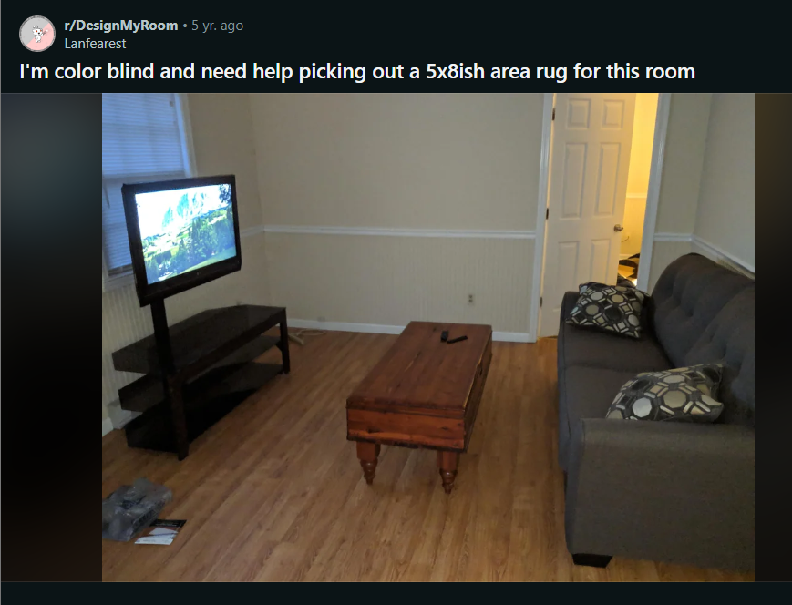

1. 5x8 is going to be too small. You need an 8x10 rug. Most common mistake I see over and over again is too-small of a rug in a living room.\n\nAs for the color/pattern. Rugs can be a really amazing statement and set the \u201cstory\u201d for the whole room. Is there something you like or are drawn to as far as pattern or color in general? Are you actually colorblind or saying that as an expression?
2. Yes! You want the rug to extend under your couch. This room was posted a few days ago and is a great example of how luxurious a large rug looks in a room: [URL]\n\nSomething with a light hand subtle pattern would look nice- light grey/white: [URL]\n\nOr if you like oriental rugs, it\u2019s a little more modern when they have a worn antiques look - like this multicolor: [URL]
3. I personally vote for the oriental colorful rug! For whatever that counts
4. I think any and all of those colors could work, although I'm leaning toward cooler colors with this room; burnt sienna wouldn't look as nice as cream, taupe, black, greens, or cooler browns.  I would get a non-color-blind person or the internet to double-check your choice, but it appears the world is your neutral/earth-toned oyster where this room is concerned.
5. I\u2019m looking at Wayfair.  They have good sales.  \n\n[Black and White geometric]([URL]\n\n[Yellow zigzag]([URL]\n\n[Light Gray]([URL]\n\n[Aqua]([URL]\n\n[Blue gray]([URL]\n\n[Gray with hints of blue]([URL]\n\nI think a mid century style would look good with the gray sofa.  \n
6. Oh wait the last one is great here + you can find great throw pillows with geometric shapes
7. I\u2019m not really sure myself, but something light like cream, or a colour that matches your wall might be alright? Maybe not even cream or beige, maybe a light grey?
8. I can't tell from the lighting, but is your couch an olive green color.  You could do a fun but simple retro theme with olives and golds.
9. I have that exact couch!!! I have a grey and white rug... so I would choose from the links that have been posted
10. I have this couch as well. I got it in October and the divot is pretty much staying the same (it hasn't gotten worse). Other than that it is holding up pretty well in my house with a dog, cat and 1 year old.
11. You need another coffee table, it doesn\u2019t go. Lol\n\nTry [this]([URL] \n\n[this]([URL] \n\n[this]([URL] \n\n[this]([URL] would be very nice, but you\u2019d have to change the cushions, which isn\u2019t too much.\n\nTry [this]([URL] for a coffee table\n\n[glass?]([URL]
12. Ahh got it lol. In the meantime, a black table runner all the way across with some hang down would tie it in to the other things.
13. I would go with something lighter since your couch and other furniture is darker. Will help with other elements pop a bit more. There are many fantastic lighter oriental rugs these days (check out lulu and Georgia or citezenry or honestly many many others) that would look fantastic here

**Post last 63(line : 916430)**

**URL : <https://i.redd.it/qyleiw1xt0q81.jpg>**



Comments :

1. I love both, but I really think the bottom one fits your venue vibe more!
2. Which castle?! Asking because we\u2019re getting married at Waterford. You look stunning both, but I love the simple look of the top one for a castle venue.
3. Stunning in both so I can see your dilemma haha! I looove the bottom one tho, can I ask which dress/designer it is??
4. Question- are you big on dancing? Do you imagine yourself tearing up the dance floor with your new hubby? If yes then I think the bottom dress is a better fit. \n\nThey both look amazing on you. The top one is stunning, but man would I hate trying to get down in it \ud83d\udc83\ud83c\udffd
5. You look amazing in both so this is hard. Bottom fits your venue better but I'm leaning towards top because not everyone can pull of this look but you do so well!
6. The top one shows off your fantastic figure. It will make jaws drop. You can pull it off.
7. They are both 100% amazing on you but I\u2019m going to go with top because that fabric is once in a lifetime and that body is once in a lifetime too.  You absolutely can and should go w dress on top \ud83d\udd1d
8. I really love the one on the bottom !
9. You are truly beautiful in both but with that figure \u2764\ufe0f\u200d\ud83d\udd25\u2764\ufe0f\u200d\ud83d\udd25\u2764\ufe0f\u200d\ud83d\udd25 I would do 1 if you\u2019re remind right show off and be a sexier bride! 2 is beautiful for a more conservative wedding
10. Bottom! Love how it looks on you and super fits your venue

.

.

.

.

.

**Post last 64 (Line - 916224)**

**URL : <https://i.redd.it/d9fo43njpzi41.jpg>**

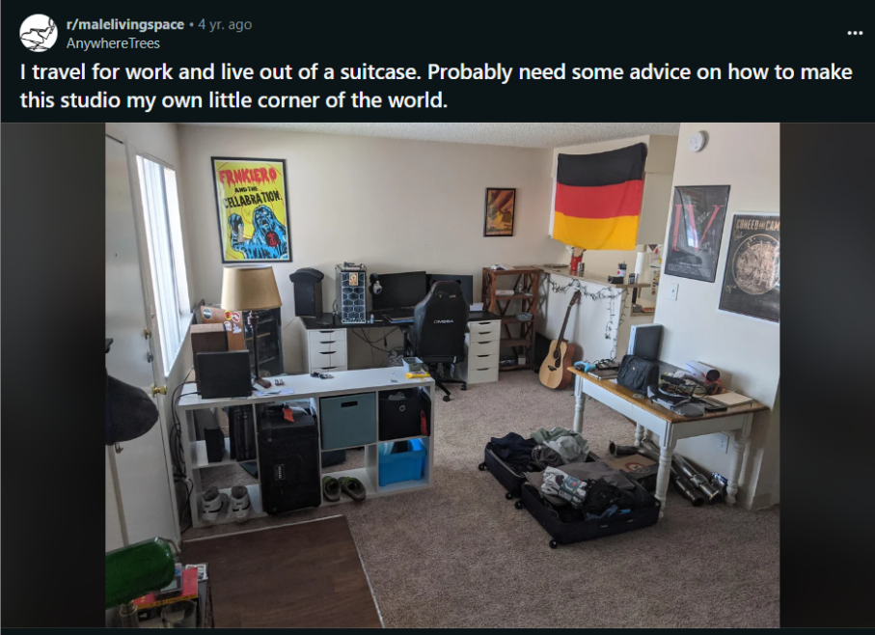

1. white shelf extrudes into an area, which makes it take up a lot a space. I\u2019m no expert but maybe moving that to a different area would open things up
2. Your storage definitely isn't working for you. Neither the white Kallax (?) nor the table are the best choices for what you need to store (the table top is cluttered with stuff that doesn't need to be on display, with all that empty space under it! A chest of drawers might be better). If changing up your furniture is an option, looking at what belongings you have and choosing from there would be good. If it's not an option, at least get more inserts for your Kallax so stuff is less on display (e.g. your shoes).
3. Looks like a bachelor pad.\n\nTo me, everything there is storage. You have shelves, drawers, cube boxes, and stuff just sitting around, but nothing really displayed.\n\nDo you get stuff from the places you travel to? Maybe put stuff on display somehow. Maybe organize/decorate to a theme. Just seems a bit haphazard as it is.
4. I'd say clear up some of the clutter and mounted pictures ( not the yellow one) and just get better storage. It needs some more height as well that extends close to the ceiling. Maybe get a tall plant unit for the area to the right of the desk. Also maybe take down the flag, change up the brown shelf to the right of the desk and change the table with the wooden top.

**Post last 65 (line - 915750)**

**URL : <https://i.redd.it/it50ztgtd5o21.jpg>**



Comments :

1. They both look great, but I prefer the one on the left on you.
2. I personally love the one on the left.
3. I think that the one on the left is a better fit and the color seems to suit your complexion, but that might be just because of different light.
4. I actually preferred the right before knowing this. I think it also fits the 1920s estate vibe a bit better. You're beautiful in both!

.

.

.

.

**Post last 66 (Line : 915278) --> Deleted**

**URL : <https://i.redd.it/as1z34bvtot81.jpg>**

**Post last 67 (line - 915006)**

**URL : <https://i.redd.it/xwdiw88vb3v41.jpg>**

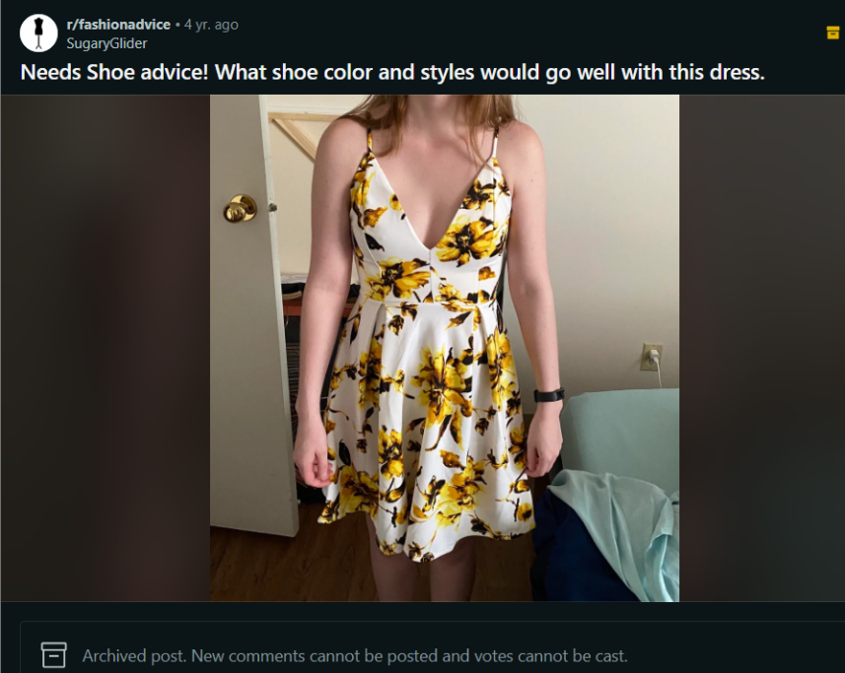

Comments :

1. Nude or white heel
2. Any color except gray, but the white and the dark tan would both be really nice
3. I like the dark tan the best personally, but you can never go wrong with black or white!
4. Nude, white or black heels. Maybe strappy heels or a pointed siletto. Cute dress
5. Nude heel or even a very pale yellow would be lovely. Nothing too shiny, so your shoes don\u2019t compete with the dress for attention.
6. Tan/brown leather strappy heel
7. i was thinking maybe some tall gladiator sandals but the ones with the lil rhinestones on them. (gold so that it will go with the yellow on your dress)
8. I'd go with tan sandals
9. I would love to see these paired with a cute yellow pump for a retro feel! \n\nBut strappy brown sandals will bring you into summer 2020
10. A nude, medium to light brown, or white shoe would be very cute. I would say a pair of kitten heels or some cute strappy heels or wedges would a be a great summery look
11. Sandals in a neutral color. Cork wedges could be fun if you want to do heels but still be able to walk on grass.
12. Tan wedges would look cute for a more casual look
13. Black sandals

**Post last 68 (Line - 914598)**

**URL - <https://i.redd.it/ryk5vsie6kx41.jpg>**

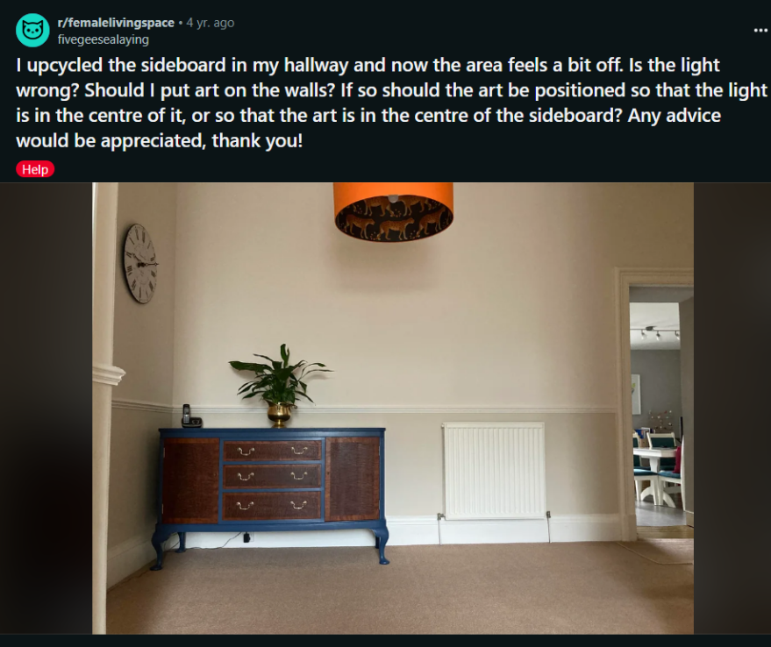

Comments :

1. >possibly add art.\n\nAnd/or hang a mirror above it.
2. I think the light is fine. I think since you can't really center the sideboard along the current wall, what about moving the sideboard on the wall under the clock? Will it fit there. And then maybe on the blank wall add a gallery wall
3. Consider putting the clock above the sideboard.  Or hanging something else once you get it placed where you like (I agree it should probably be centered between the radiator and the side wall).  Having art or a clock or a mirror above it will anchor it and make it look like it's supposed to be there.  Even a bigger something added to the surface of the sideboard, something chunky or tallish.
4. I concur with my companions here. I would move the sideboard closer to the heater and put a mirror above it or a piece of art. Then it will seem like the main event.
5. Have you thought about rotating the sideboard to the other wall, under the clock? It seems like it might fit there. I agree with the other commentator who said a runner would help, and additional art in that wall would also bring it together.\n\nEdit: One additional smaller plant on top of the side board would also help make it look more in place.
6. I'd move the sideboard so it is right in the middle of the space between the corner and the radiator, and I would hang something colourful above the radiator, or if you could get something long that fills the space between the door frame and the corner, that would be great.  I love what you are doing with the navy/orange/brown/green/brass.
7. Was going to suggest the same.  Something that creates balance on the right, above or in front of the radiator.
8. I also think moving slightly will help. The sideboard and light are so distinctive that I don't think the beige walls/clock are keeping up, maybe? I would consider a crisp white wall and fun rug. Your pieces are great.
9. I would put it closer to the radiator and then put something light in that corner. A tall plant, a light colored coat stand, etc. It can be smaller, but something to balance the colors and shadows a bit more.
10. I'm wondering if there's a way to disguise the radiator. Maybe a taller shelf like structure that conceals it a little but also allows for ventilation and heating. Or a bench for seating if this is in your foyer would useful when putting on shoes, etc. Ooh, a large leaning mirror in front of it? Ok, I'm getting out of hand. But then the sideboard would look centred in its new home between your wall and its new partner furniture. Art centered over sideboard for sure. No on will look at the artwork in relation to the light fixture I think.
11. I'm wondering if there's a way to disguise the radiator. Maybe a taller shelf like structure that conceals it a little but also allows for ventilation and heating. Or a bench for seating if this is in your foyer would useful when putting on shoes, etc. Ooh, a large leaning mirror in front of it? Ok, I'm getting out of hand. But then the sideboard would look centred in its new home between your wall and its new partner furniture. Art centered over sideboard for sure. No on will look at the artwork in relation to the light fixture I think.
12. You're on the right track. I think it needs more. \n\nHow often do you use the heater. I'd center the sideboard or move it as close as you can. Add a runner carpet and two more it's to the top of the sideboard. A coat rack or shelves could add to the space as well.\n\nYou could also hang a black and white photo above the sideboard
13. In my opinion the colours are all wrong...Your carpet and walls are three different cream/biege colours, and then the sideboard is a dark brown with dark blue. Honestly I would consider repainting the bottom of the walls to match it (like a colour of blue that is darker than the walls currently are, but not as dark as the sideboard.) It looks a bit jarring having the whole hallway be very bright and then this dark piece of furniture. Or you could repaint the blue trim on the sideboard to match your hallway more. OR you could repaint the bottom part of your walls in a darker colour that would contrast with the blue, but in a nice way, like a terracotta. The greenish biege you have already just isn't doing it for me. \n\nAdditionally, the light is orange, so that is another colour that doesn't match - If you got a gold light fixture it would match the plant and the drawer pulls, which could be good.\n\nAnother option you could do is get a big piece of art that matches the blue in the sideboard or the brown in the sideboard, or both. You could also get like a persian style rug with the blue and in it, which would get rid of some of the beige and go with the drama you have going one with the plant pot/sideboard combo.\n\nI agree with what people said about moving it to the centre of the wall if possible
14. While your suggestions might indeed work well in a different environment, right here I am afraid OP would risk ending up with a contrived setup and trying too hard. IMO the given colours are not only totally fine, but OP has already managed an effortless combination: all those shades of beige, sand, cream and brown - including the orange lampshade - are adjacent colours on the colour wheel. By adding the complementary blue they have achieved an excelllent harmonic combination of colours.\n\nOP, as others have already said, just move the sideboard slighly away from the wall and I am positive you'll notice an instant upgrade already. Your colour choices are wonderful as is that georgous lamp. Keep up the good work. :)

**Post last 69 (Line - 913835) --> Deleted**

**URL : https://i.redd.it/t3nne88t1fs91.jpg**

**Post last 70 (Line - 913615)  
URL : <https://i.redd.it/7bdzwt3h27g51.jpg>**

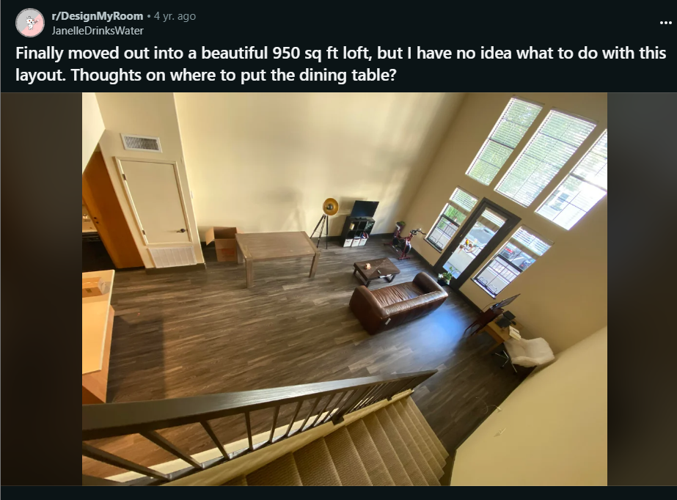

Comments :

1. I'd do the dining table with the long side parallel to the kitchen counter. You should still have enough room to walk and it gives a nice divide between kitchen and living room. Also, please get a big enough rug for the living room area to define the space and make it cozier (in open areas like yours, it's important to define spaces). At least the front legs of the sofa and the entire coffee table should be on the rug. I think one side chair could work on the side of the balcony if you move the rest a bit to the left, but two chairs (one on either side) would be too much, especially with the dining setup.\n\nIf you're only going to use the dining setup as a creative space, maybe consider putting the living room setup more near the kitchen (tv under stairs or in front of them, sofa facing it and standing freely in the room with enough way to walk behind it, coffee table in the middle, also a rug there) and put the dining table where the tv is right now with the longer side facing into the room. Hang some are above where the dining table touches the wall to define the space.
2. Agree with others about the dining table. Move it 90\u00b0 and bring it closer to the kitchen. You could put it directly under the counter, but I'm not a fan of that look. I'd pull it a few feet away. Assuming you have chairs around it. \n\nA rug in the living room is pretty necessary to define the space. I don't think it's necessary for the dining table, I don't tend to like rugs under tables for food. \n\nYou asked about side tables. I wouldn't recommend them. Unless you really need to get a lamp right next to the couch. If you do need one, I would add just one. Don't think that you always have to have a pair.\n\nFor your workspace, I think you could make it look a little more defined and clean with a few changes. For one, I would get a arm for your monitor so that you can mount it to the desk itself without a separate piece of furniture. Right now this looks kind of haphazard. Also, if you need storage space like cabinets or shelves for books, I'd put those on the wall. It might help to put something tall on the wall there. Or something decorative. Depends how you want to use the space.\n\nFinally, you might want to consider moving the exercise bike to where the dining table is now. Depending on the layout, it might help hide it a little bit more. I'm trying to imagine the space as you walk in the front door... I'm guessing the desk area is kind of hidden by the stairs at first glance. But that exercise bike is kind of in the center of the view. by the way, I'm not entirely sure that would be the best place for the bike, but it might be worth the try. I'd put it parallel to the wall facing the windows.
3. Had the same thought about dining table placement. Basically extending the kitchen island.
4. Area rugs will make all the difference in designating your spaces. Consider one for the living area, and one for under the dining table. Turn the dining table 90 degrees and pull it out from the wall more and move it a bit closer to the kitchen
5. I\u2019d probably put one small table on the left side of the sofa. I think for lighting a floor lamp would be a better choice.  Is that a lamp by your tv?\n\nI like the desk where it is.  \n\nOne problem I see is no electrical outlets to power anything near the sofa. I\u2019m sure there\u2019s a solution though.\n\nOh, and some color. That rug should be really large and might be your color palette. Maybe a couple of throw pillows and a cozy blanket or throw.\n\nThat wall space is so vast, consider several large pictures, or see that wall as two separate spaces, so one large picture and a gallery wall or textile on the other end. This would be a great place for a wall hanging like a Navajo blanket
6. Do you need a dining table if you have that island bar? I prefer keeping things open and not having too much large furniture, so I\u2019d just get some nice bar stools for the bar and call it good.
7. Bar stools. Use the island as your dining table.
8. Between the kitchen and the living room

Post last 71 (Line : 912903)  
URL : <https://i.redd.it/09ksfn1hont41.jpg>

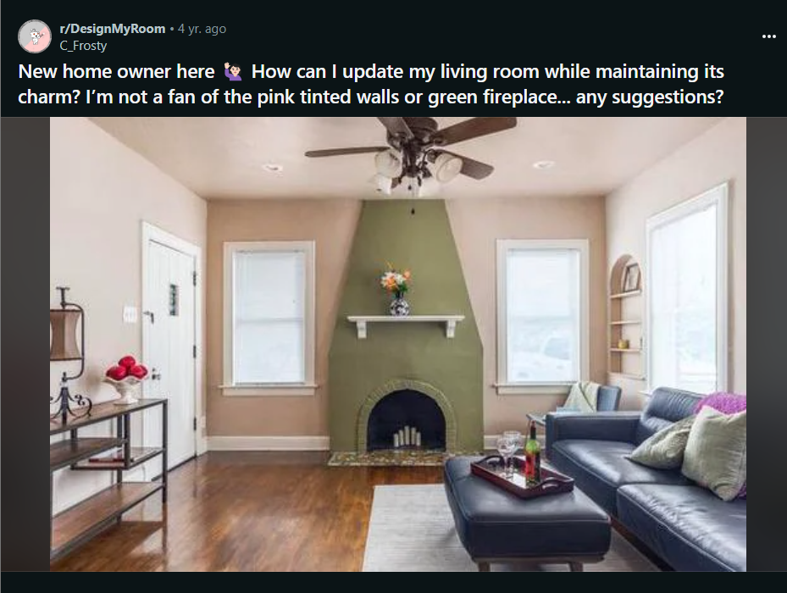

Comments :

1. Wood shelf would make a huge difference

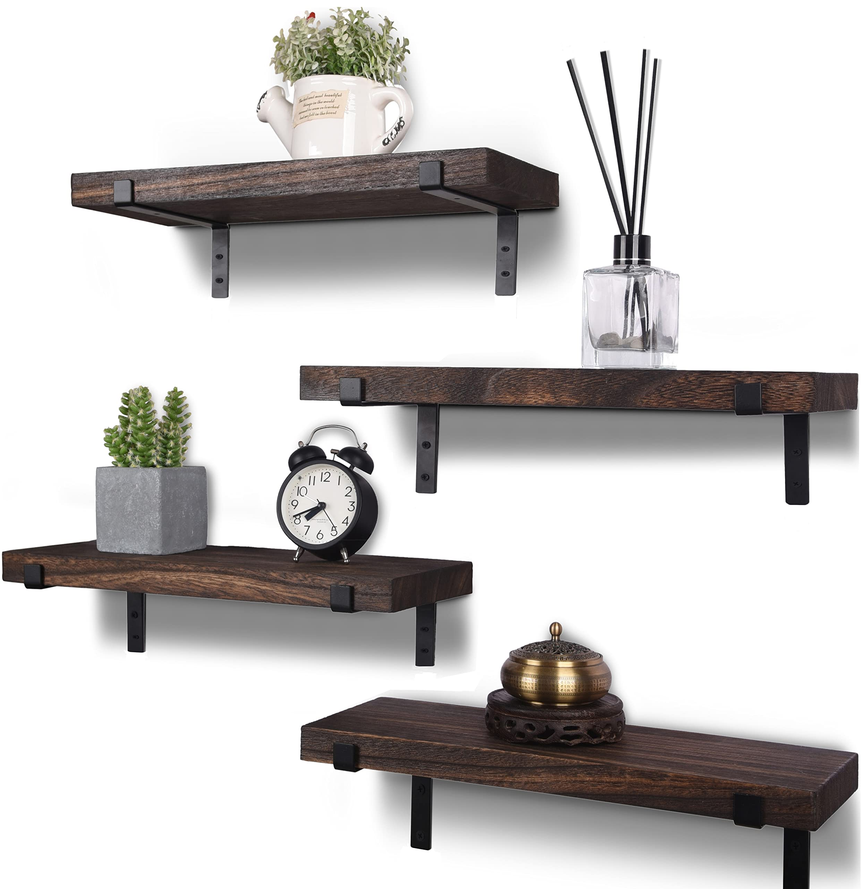

1. I also think the fireplace looks great, I wonder if you would like the fireplace more if you paint the walls a color you like that goes with the fireplace. I don't know what color that would be though. Congrats on the lovely home!
2. I think an off white would be nice. The current colour is sort of a blush pink, but any not-quite-white without a green tone would be nice. I'm looking at Sherwin Williams Downy SW 7002 or Ceylon Cream SW2354

 

1. I love the green as well. I\u2019d prefer no pink on the walls but that fireplace is gorgeous.
2. I think I'd try painting the bricks along the opening a lighter color for contrast
3. i actually think this room is really nice.  honestly thought it was r/AmateurRoomPorn at first.  i think the colors work really well together and i even really like the ceiling being painted the same as the walls.  i would hesitate to repaint the fireplace white unless it really doesn't align with what you like.\n\n&#x200B;\n\ndefinitely replace that ugly ceiling fan light but i actually disagree with the other posters saying to add crown molding.  i think the squareness of the room helps with the aesthetic and adding crown molding would make it feel congested
4. I personally love the green fireplace. It\u2019s so unique. I\u2019d go with other people\u2019s suggestions and paint the pink walls first. Do an off-white with an undertone that wouldn\u2019t clash with the green paint. Maybe a gray-based or slightly yellow-based undertone? Try a few swatches. If you do hate the green, then I\u2019d paint the fireplace a navy blue or even a muted black or slate if you want a statement and focal point. And then, again, a neutral white or off white for the walls.

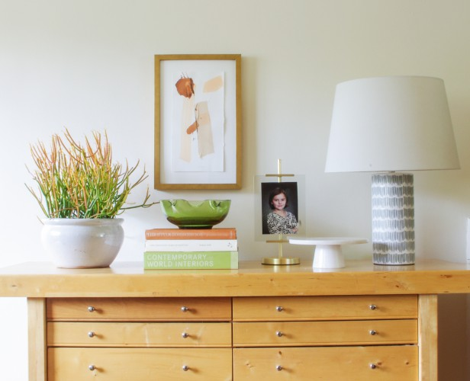 

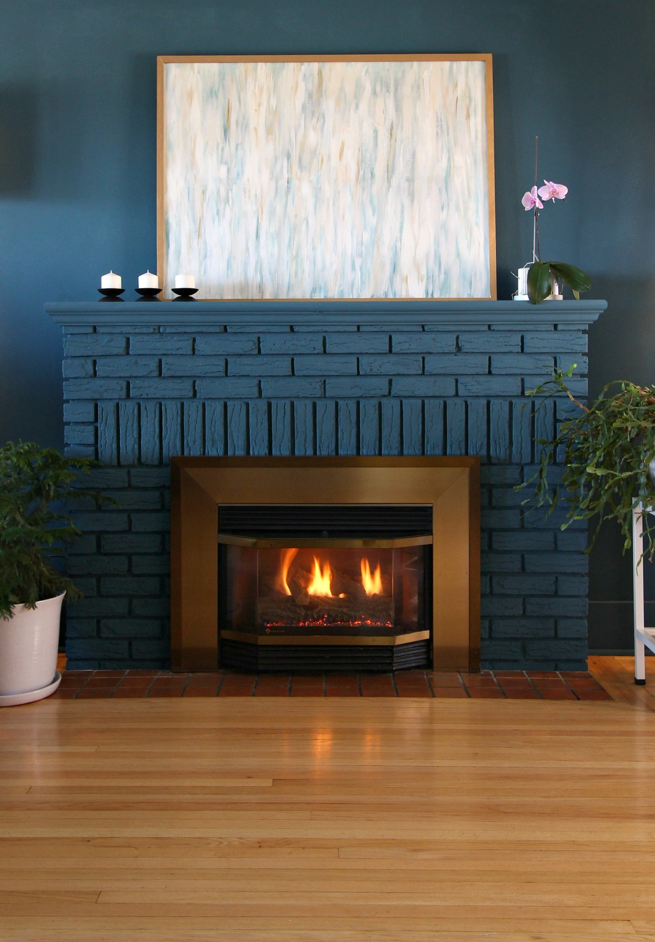 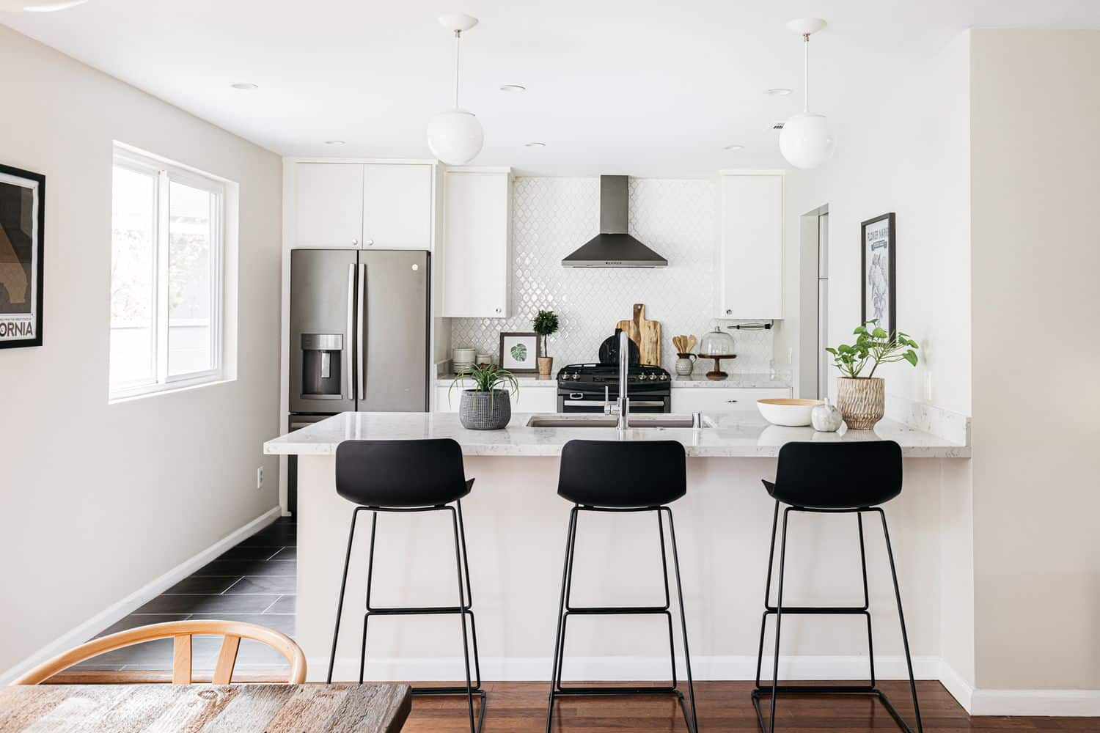

1. This is a gorgeous room, but I'm not a fan of the colors. If you're into neutrals, you could consider a charcoal/ black colour for the fireplace and white walls. The windows are perfectly placed!

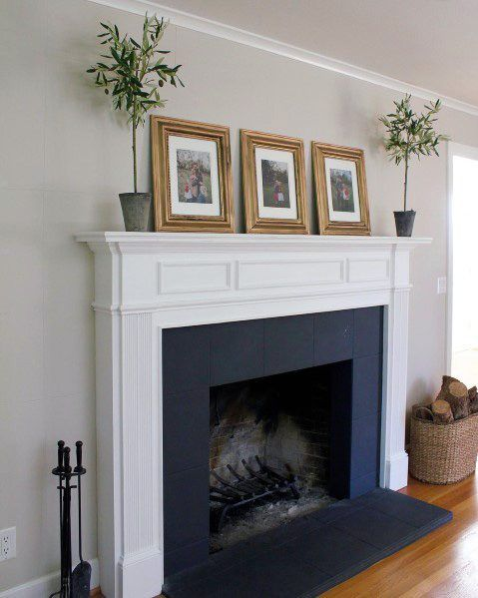 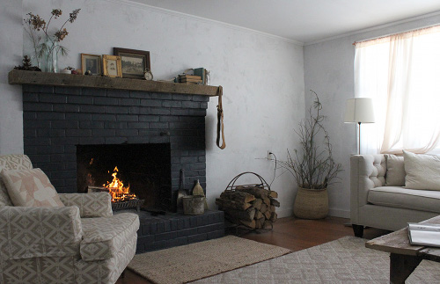

1. I thought that too. A nice dark colour for the fireplace, and a lighter colour on the rest of the walls. I see a lot of people like the green but I think it's horrible haha.
2. How would you furnish a black and white room like that? Black and white furniture? Bright colors? A big red sofa and everything else in grays? It\u2019s not at all my style so I\u2019m just really curious.

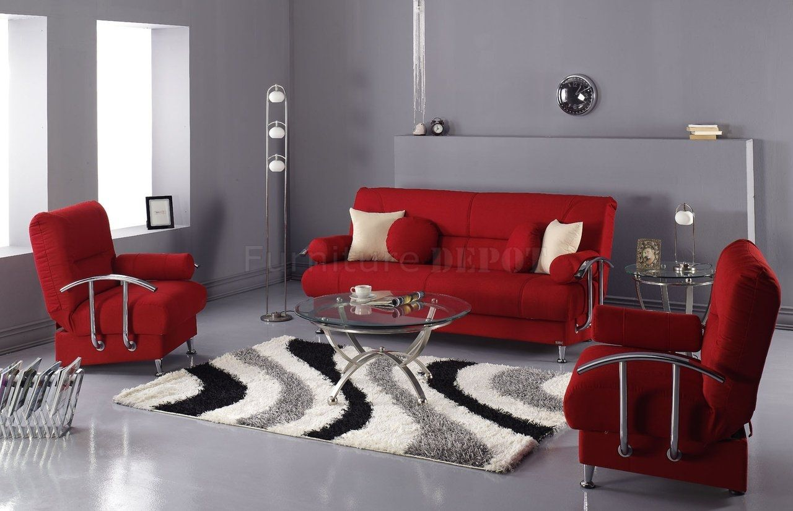

1. I was also thinking black for the fireplace and white walls. But I think we\u2019re in the minority here haha.

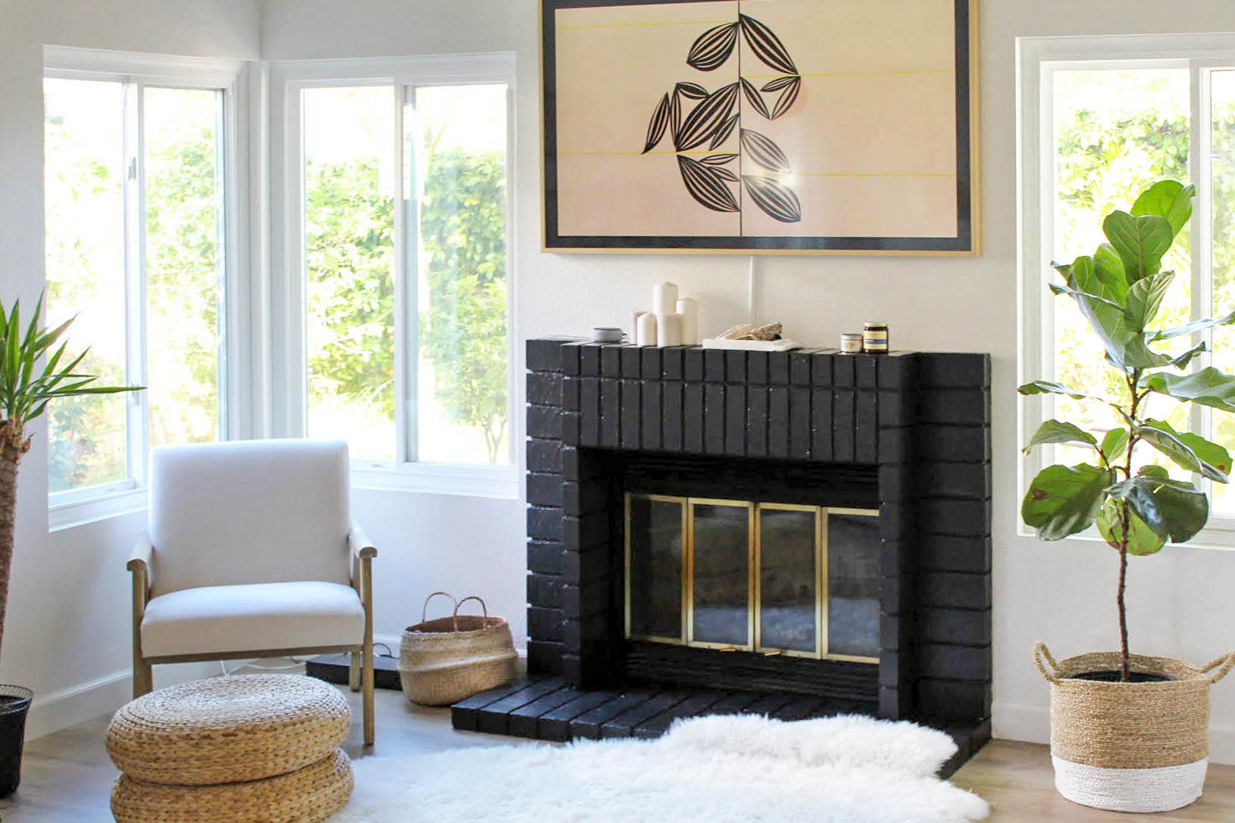

1. I was also thinking this. Or black accent wall and white fireplace with a large natural wooden mantle.

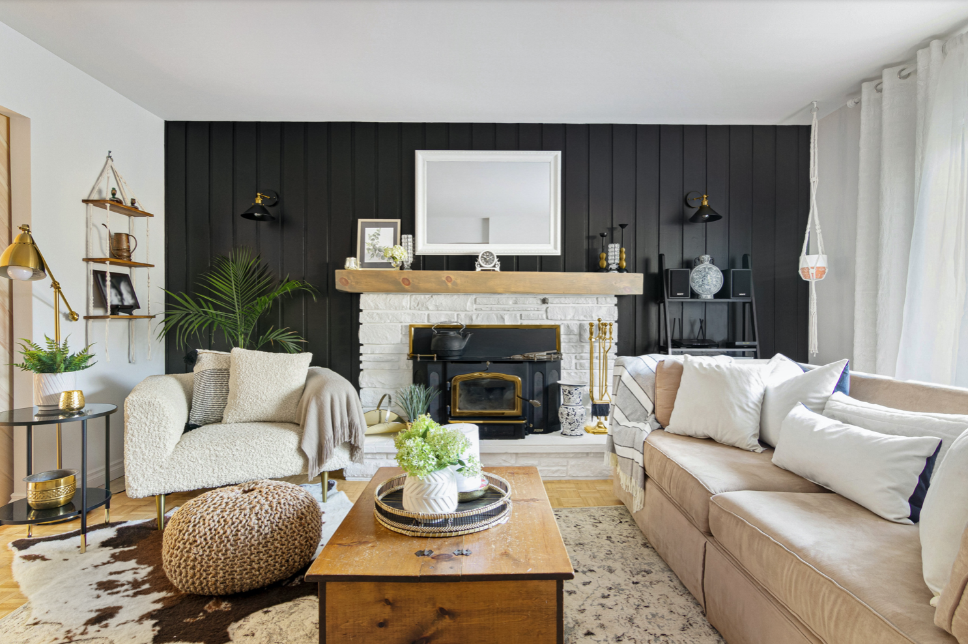

1. of course the answer it paint, since you don't like the colors.  i think the wall around the fireplace is a great place to start before committing to something for the whole room.  you can leave the fireplace green while you find your main color.  and, if you can find something you love that doesn't clash, you might be able to avoid painting the ceiling.\n\nor, if you decide to paint the ceiling, maybe that and the fireplace could be the contrasting colors.  make sure to show us when you're done!
2. Paint the walls white or agreeable gray first, then see how you likenthe fireplace- I think the green looks great on its own but terrible with the pink.\n\nLean heavily into mid century modern for this home.

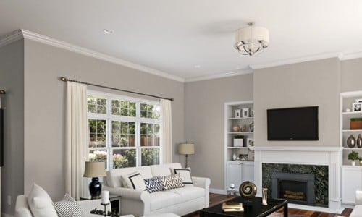

1. I love the paint colors. The mantle shelf is too small/ wrong scale IMO and ceiling fan is dated.\nEdit: clarity
2. If this were my room, I'd go for a deeper green personally, like bottle/forest rather than this sagey/olive.\n\nAgree with everyone saying paint the room an off-white first but I really came here to comment on the shelf - it should be much lower to properly frame the fireplace. Seems really like an afterthought at the height it is!
3. This room is absolutely adorable imo, maybe neutral furniture and some wall decor? If you wanted to repaint the other walls grey tones help modernize.
4. I think this room is gorgeous as is. The only thing I would change is replacing the ceiling fan with some other light fixture. That particular style is really dated. I think it would be helpful to see some of your actual furniture since you said this is staging.
5. It looks as if they pulled that green from the tiles in front of the hearth. I suggest following suit and pulling another color from the tiles for the fireplace, and something complementary for the walls.It's hard to see from the picture, but it looks as if it's green, terra cotta, and white? So, maybe, terra cotta for the fireplace and a soft green, creamy yellow or off-white for the walls and the painted brickwork. I would also remove the white shelf and either install a rustic, reclaimed wood shelf mantle, lower, where you can see that line, or else hang a colorful or sculptural piece of art in its place.
6. Also not a fan of the green, but I just saw a house with a similar fireplace setup that was painted a [brightish navy with a natural wood mantle] ([URL] I think a similar combo would look nice!
7. [Grey walls, blue fireplace]([URL] [grey rugs]([URL] [blue armchair]([URL]
8. Keep the fireplace green and paint the wall surrounding it black. Make sure you give the white accents a fresh coat to make them really pop. \n\nI would suggest painting the other walls white, and the inside of the bookcase either the green or black to match the room.\n\nI would replace that mantle with something a little more robust and also white. \n\nI honestly love the room, but not a fan of the tan/ pink color either.
9. How would you furnish a black and white room like that? Black and white furniture? Bright colors? A big red sofa and everything else in grays? It\u2019s not at all my style so I\u2019m just really curious.
10. I love the green.  My suggestions, updated ceiling fan, or at least updated lights, rug, art, throw pillows and a can if paint can erase the pink -- it's pretty, but doesn't vibe with your sofa.
11. I'd leave the fire place green, paint the wall it's against black as an accent wall, and the rest white! \n\nIf you're not a fan of the fireplace, maybe a nice navy blue would be good.
12. Great room! I suggest some house plants!! Perhaps a tall stalky dracaena or fiddle leaf fig to put behind the chair. Medium brushy plant in front or side of fireplace opening. Something viney or dealing on one side of your mantle. And a few small plants on your table on the left. Maybe a taller medium size bush by the door. Whatever you choose I think some plants can really tie a room together and fill that \u201cvoid\u201d we sometimes think there is
13. Off white flat paint paint on the fire place and walls, bring it tp life through furniture and flooring, fixtures
14. It needs curtains (patterned, color with white), artwork over fireplace, entry way rug. I do not see a need to change up paint until the colors are balanced. Interior of shelving unit could be painted. Brick around hearth as well.
15. I'd do very light pale blue sides and a tree-trunk colored fireplace... so many trunk color options
16. I would paint all the green on the fireplace white and install a large natural dark wooden mantle (think Santa Barbara style.) where the circle of bricks are around the fireplace replace with a strip of decorative Spanish or some other style ceramic tiles.
17. I agree with others that the design/shape of the fireplace is stunning. But I agree with you that the color combo seems off. I would like the green more if the surrounding wall was painted grey or off-white. And I would like the pink walls better if the fireplace was painted white. Green and pink (which is really just light red) are kind of contrasting colors, so they definitely look a bit off together in my opinion.

**Post last 72 (Line - 912149)**

**URL : <https://i.redd.it/cycb2djsd1l81.jpg>**

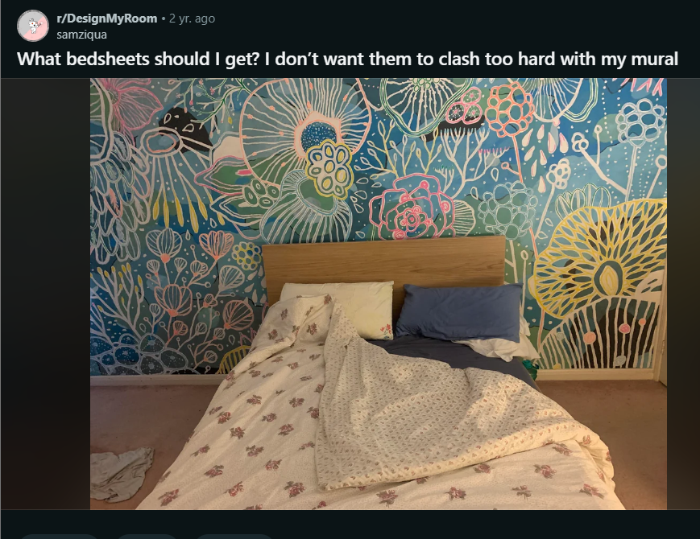

Comments :